Myxomatosis

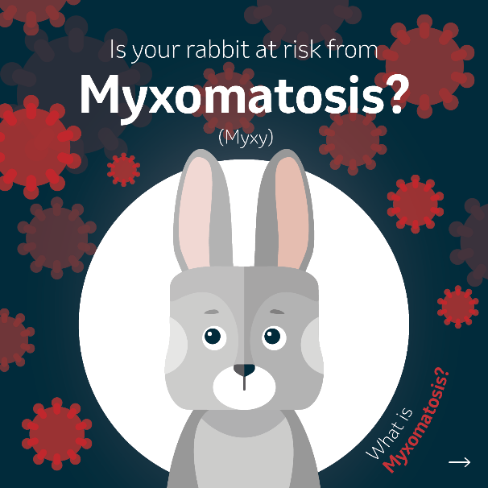 | 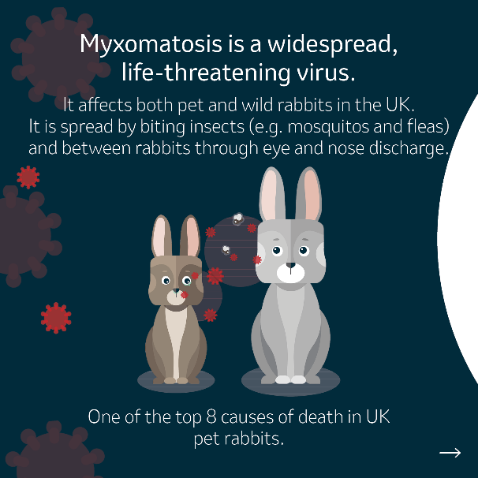 | 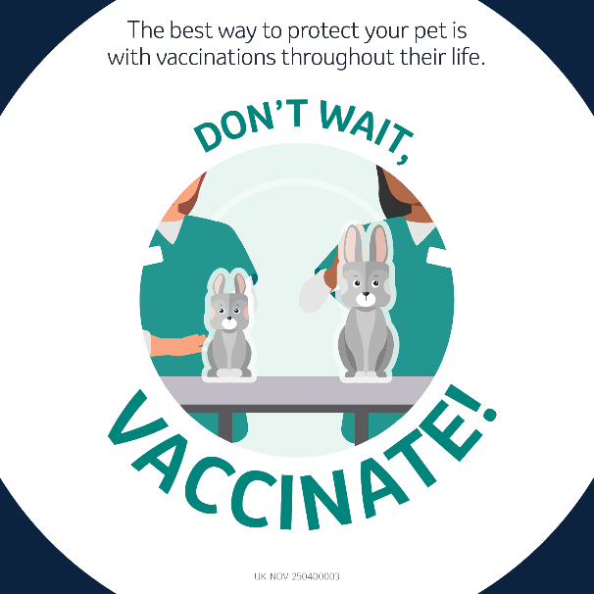
Suggested Caption:
🐰 Myxomatosis is a widespread, life-threatening virus ⚠️

Cases are seen frequently in unvaccinated rabbits, causing tumour like swellings and decreases the rabbit’s ability to fight infection, so they tend to catch additional bacterial infections that cause severe respiratory disease.

The best way to protect your rabbit is with regular vaccinations throughout their life. This not only protects them, but also decreases the spread of disease. Check with your vet today if your rabbit’s vaccinations are up to date.

Find out more: uk.mypet.com/vaccinate/

#IAmProtected

Rabbit Haemorrhagic Disease (RHD)

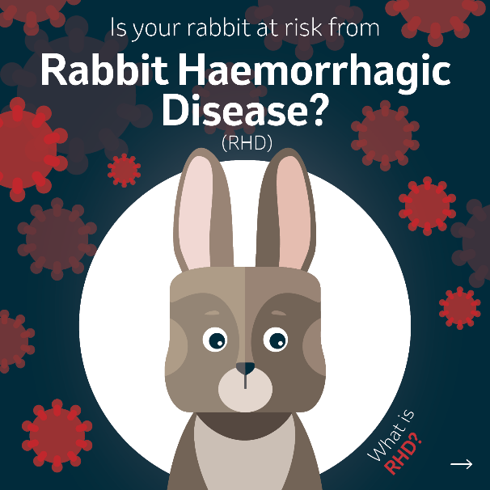 | 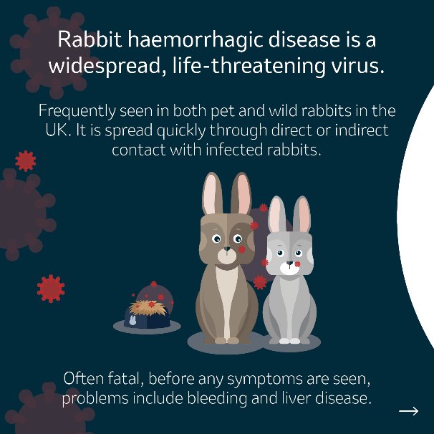 | 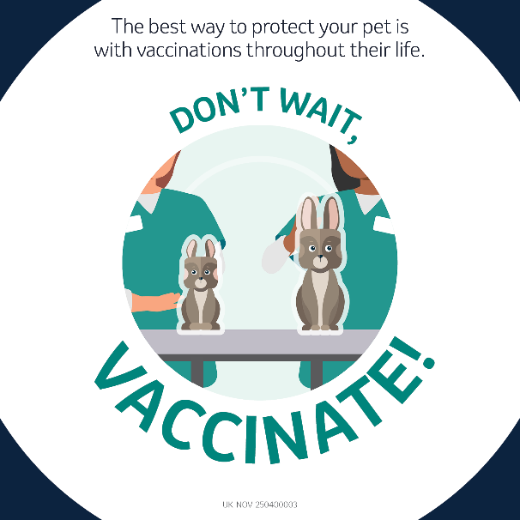
Suggested Caption:
🐰 Rabbit Haemorrhagic Disease is a widespread, life-threatening virus ⚠️

Often called viral haemorrhagic disease, this is seen frequently in unvaccinated rabbits because it spreads quickly through direct and indirect contact with infected rabbits.

The best way to protect your rabbit is with regular vaccinations throughout their life. This not only protects them, but also decreases the spread of disease. Check with your vet today if your rabbit’s vaccinations are up to date.

Find out more: uk.mypet.com/vaccinate/

#IAmProtected

Alternative first slides, better suited for Facebook layout.

Myxomatosis | Rabbit Haemorrhagic Disease
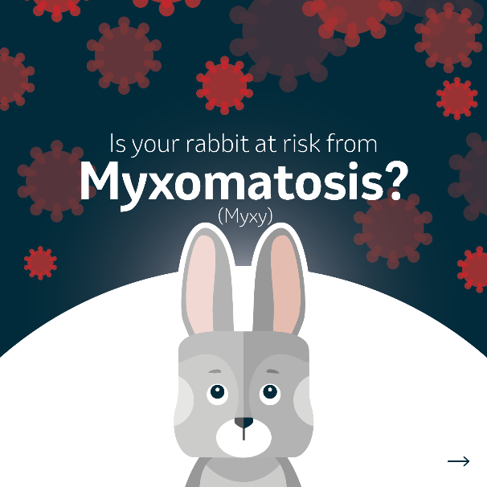 | 