Parvovirus

Option 1 | Option 2
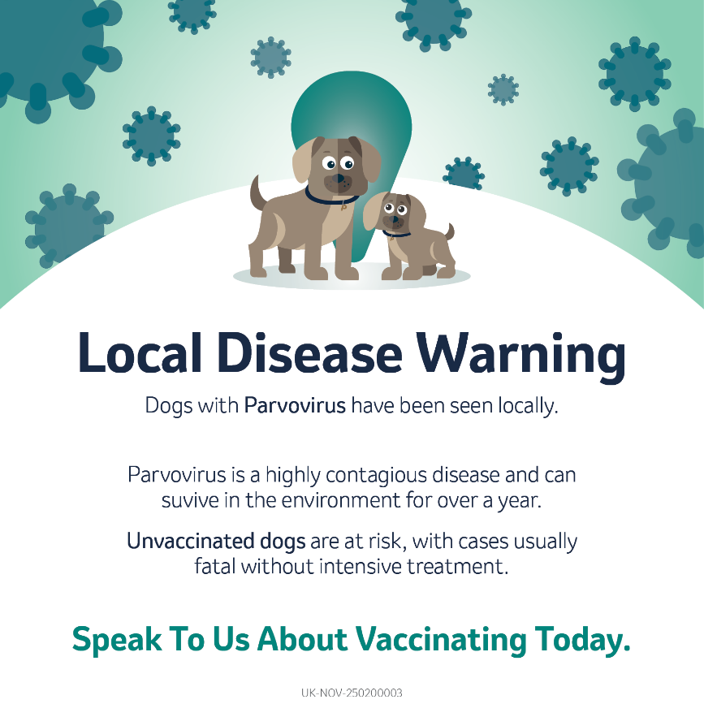 | 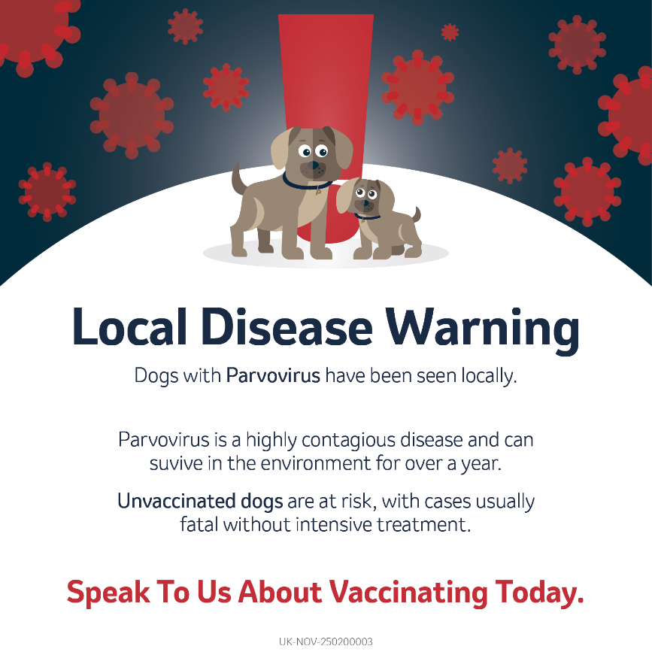
Suggested Caption: The best way to protect your dog is with regular vaccinations throughout their life. Unvaccinated dogs are at risk and it is usually fatal without intensive treatment. Don’t wait, vaccinate!

Leptospirosis

Option 1 | Option 2
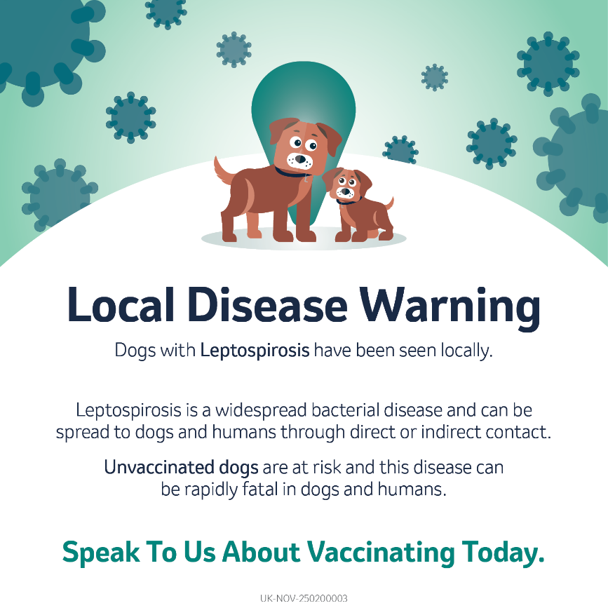 | 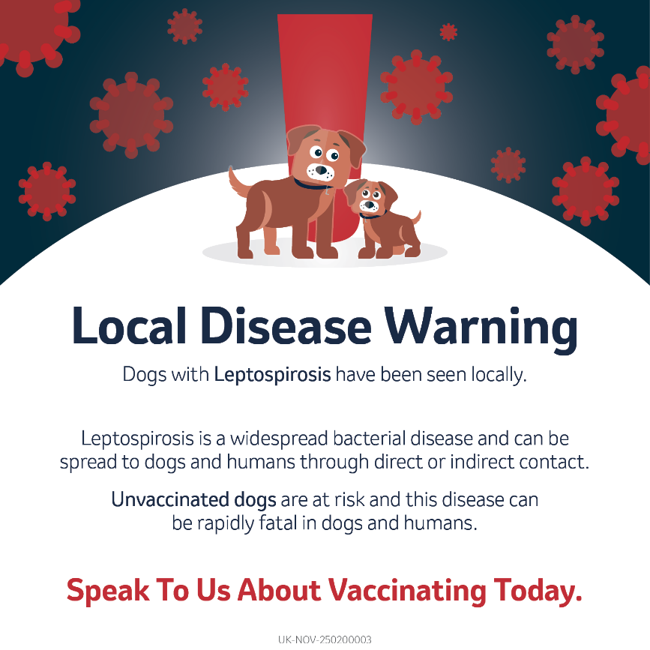
Suggested Caption: The best way to protect your dog is through yearly vaccinations throughout their life. Unvaccinated dogs are at risk and it can be rapidly fatal in dogs and humans. Don’t wait, vaccinate!

Contagious cough

Option 1 | Option 2
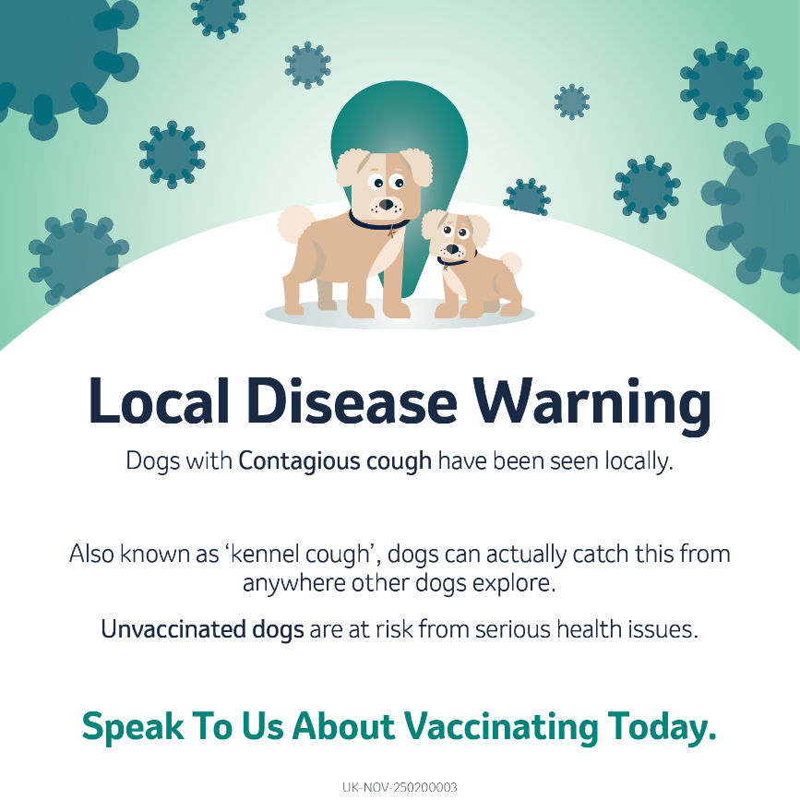 | 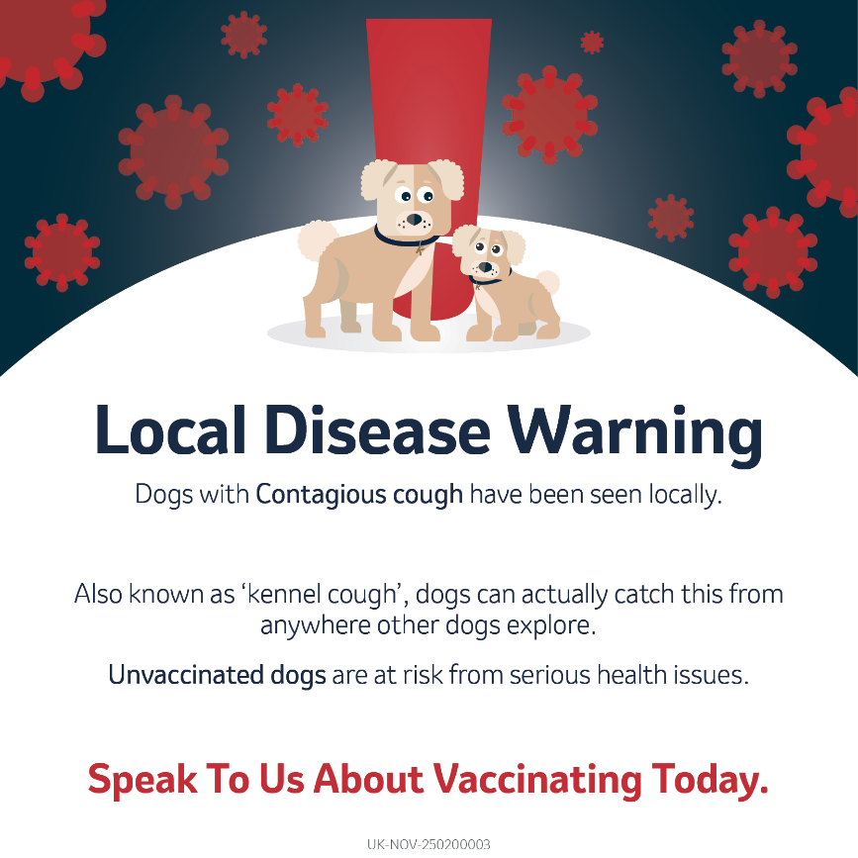
Suggested Caption: The best way to protect your dog is through yearly vaccinations throughout their life. Unvaccinated dogs are at risk from serious health issues. Don’t wait, vaccinate!

Cat flu

Option 1 | Option 2
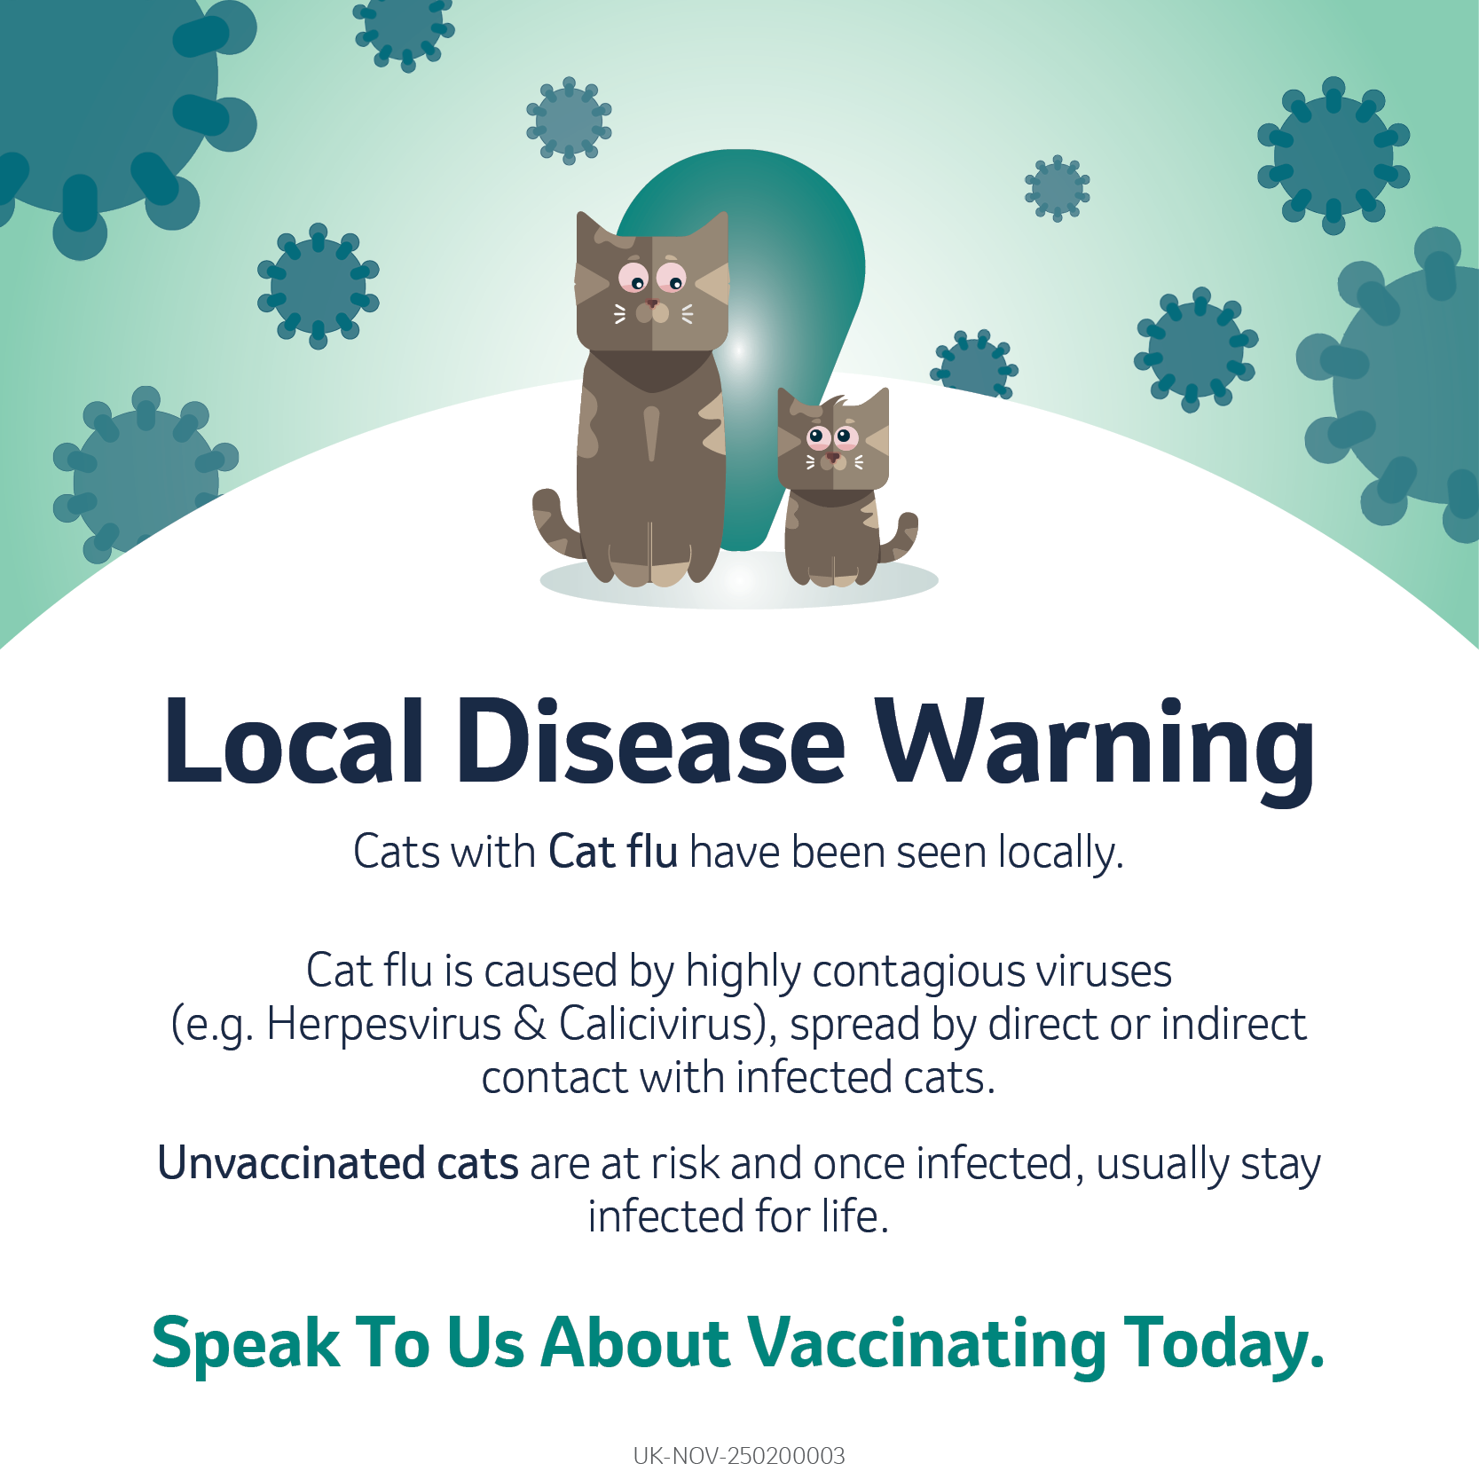 | 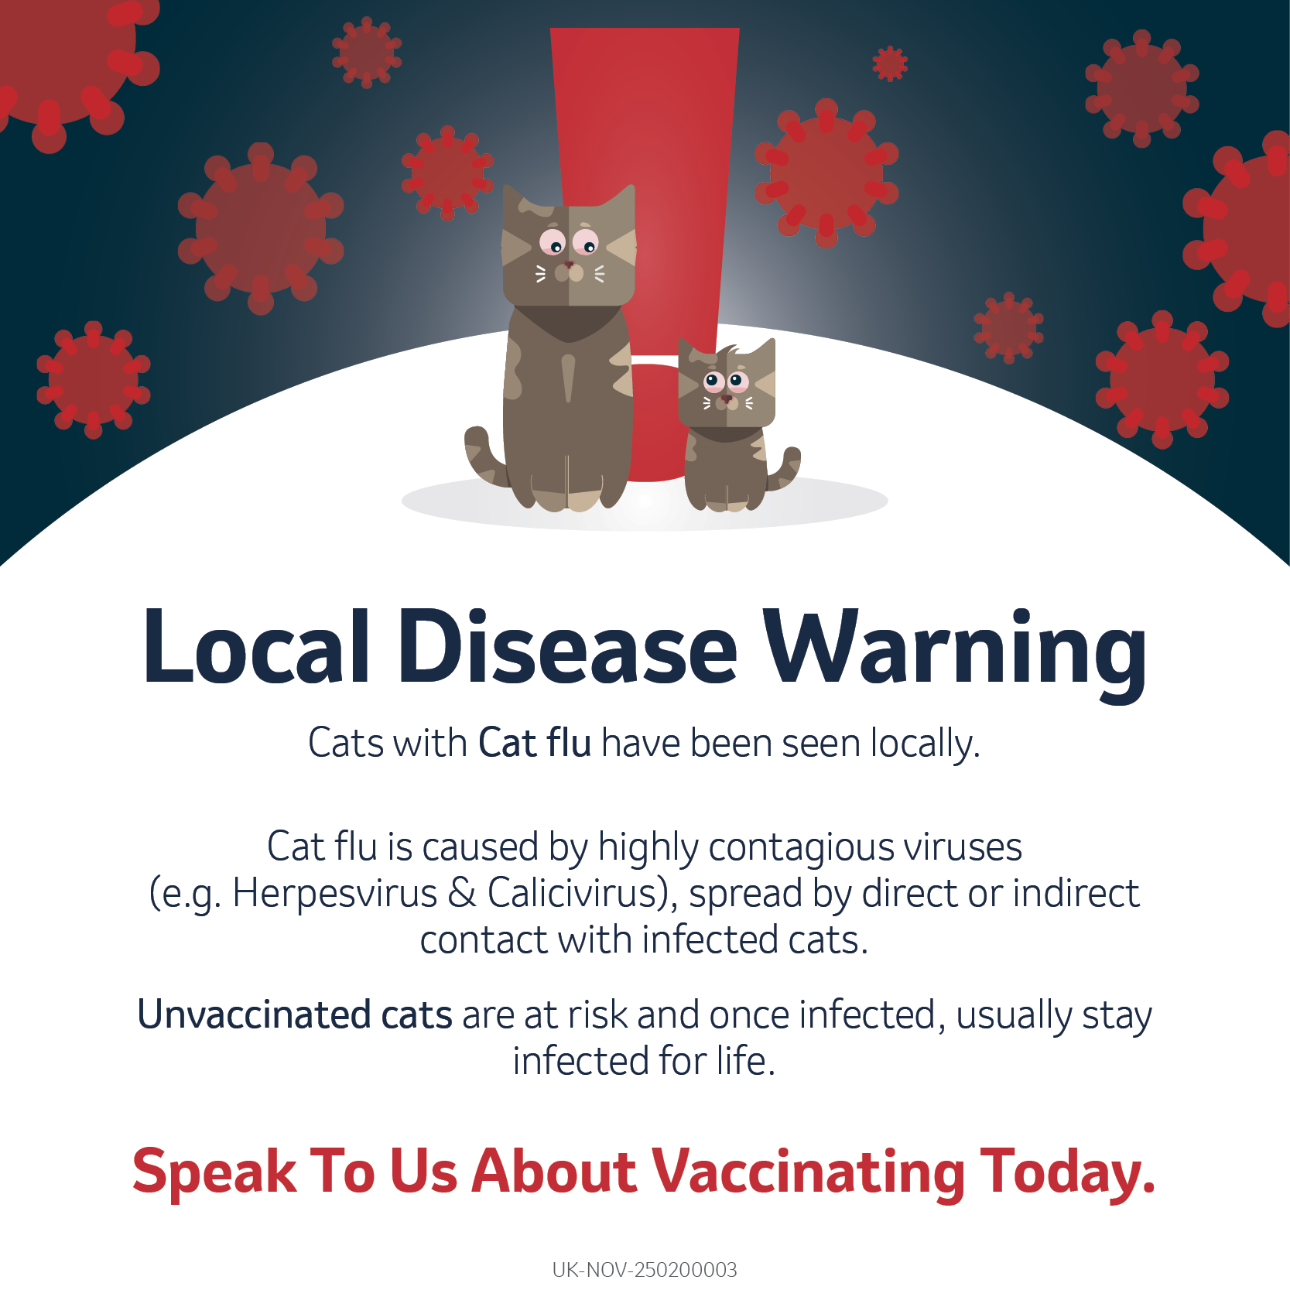
Suggested Caption: The best way to protect your cat is with yearly vaccinations throughout their life. Unvaccinated cats are at risk and once infected, usually stay infected for life. Don’t wait, vaccinate!

Feline leukaemia virus (FeLV)

Option 1 | Option 2
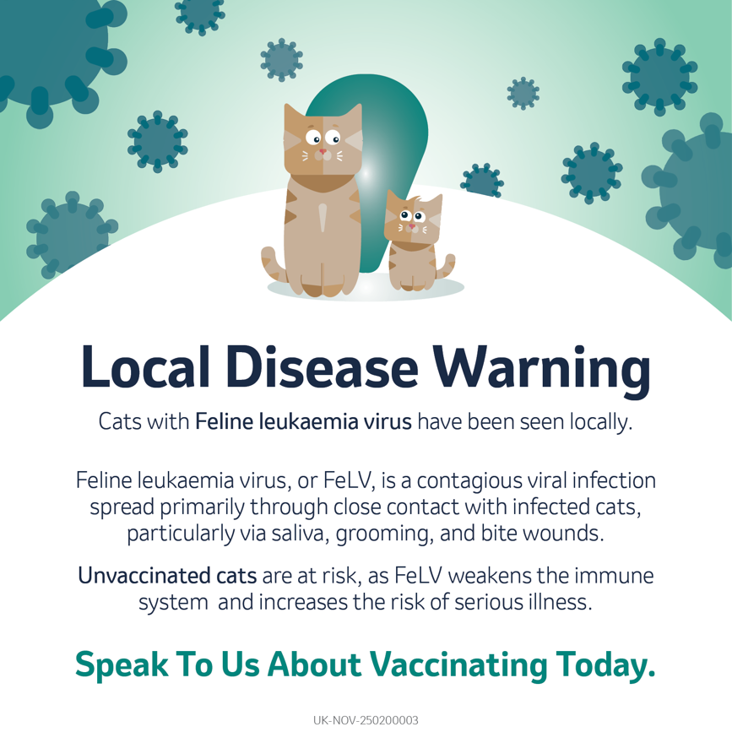 | 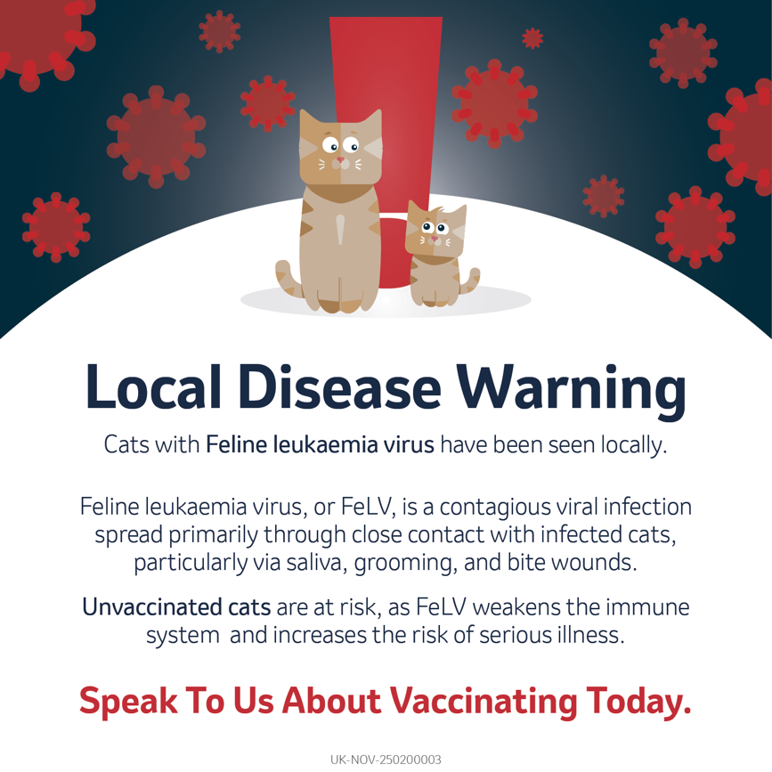
Suggested Caption: The best way to protect your cat is with yearly vaccinations throughout their life. Unvaccinated cats are at risk of serious illness that can often be fatal. Don’t wait, vaccinate!

Panleucopaenia

Option 1 | Option 2
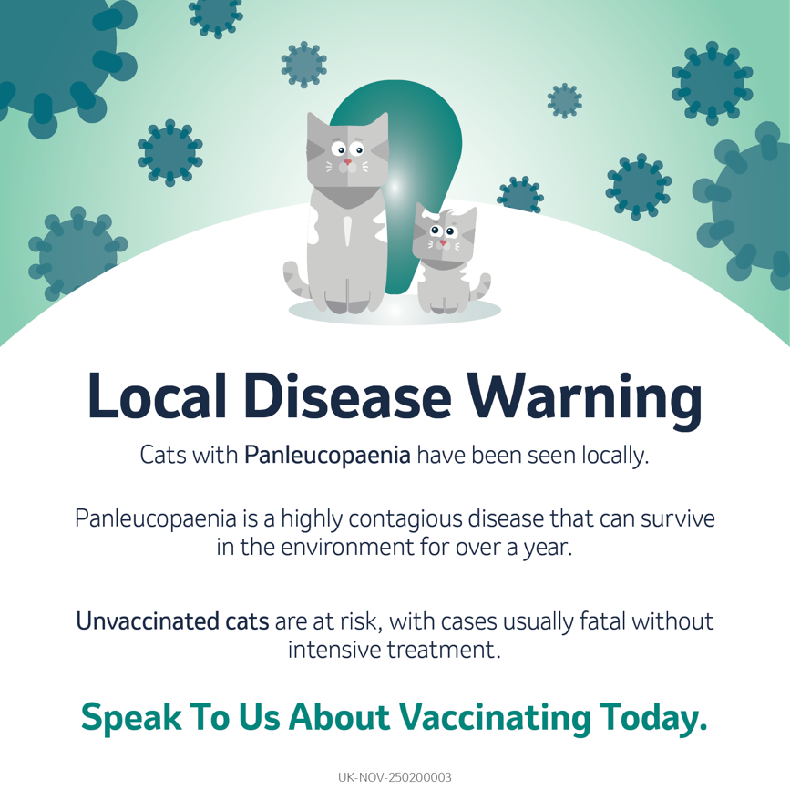 | 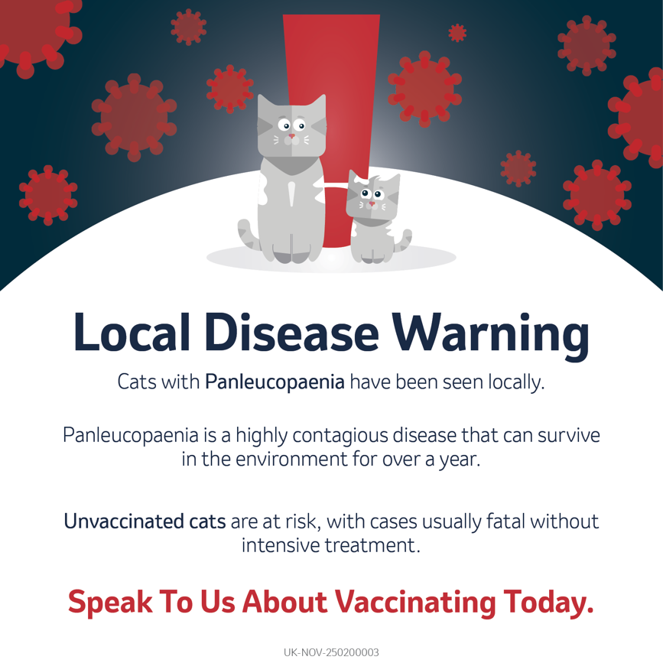
Suggested Caption: The best way to protect your cat is with yearly vaccinations throughout their life. Unvaccinated cats are at risk of fatality without intensive treatment. Don’t wait, vaccinate!

