For text: Copy and paste straight from this document onto your clinic’s social media page.
For images: Right-click and ‘Save as Picture’ to your files, then upload to your social media page from your saved files.
Social Media Posts
Post #1
That ‘harmless’ puddle could spell trouble for your dog. Leptospirosis spreads from direct or indirect contact with urine of dogs or rodents in water. Protect your dog from leptospirosis. Contact us to book your vaccination today.
Even healthy-looking dogs can spread disease, and adult dogs need yearly boosters to stay protected. Find out more: uk.mypet.com/vaccinate/

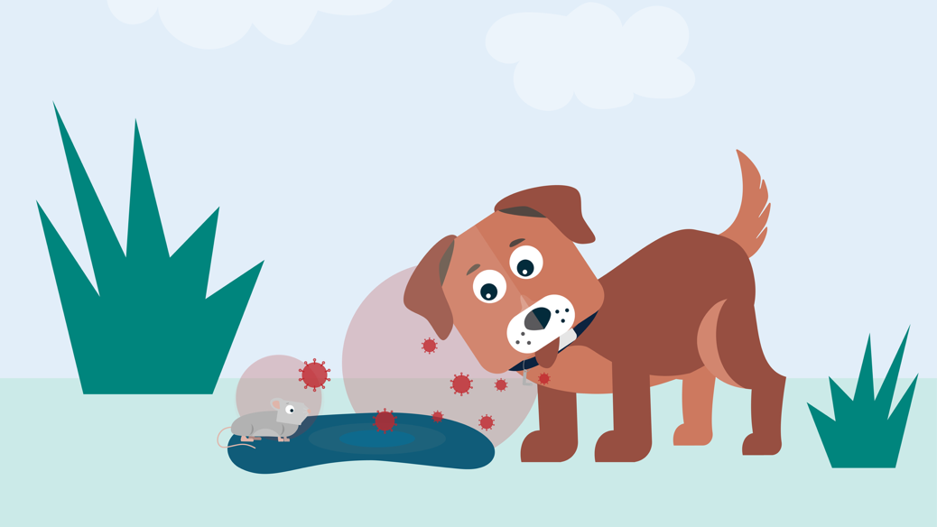
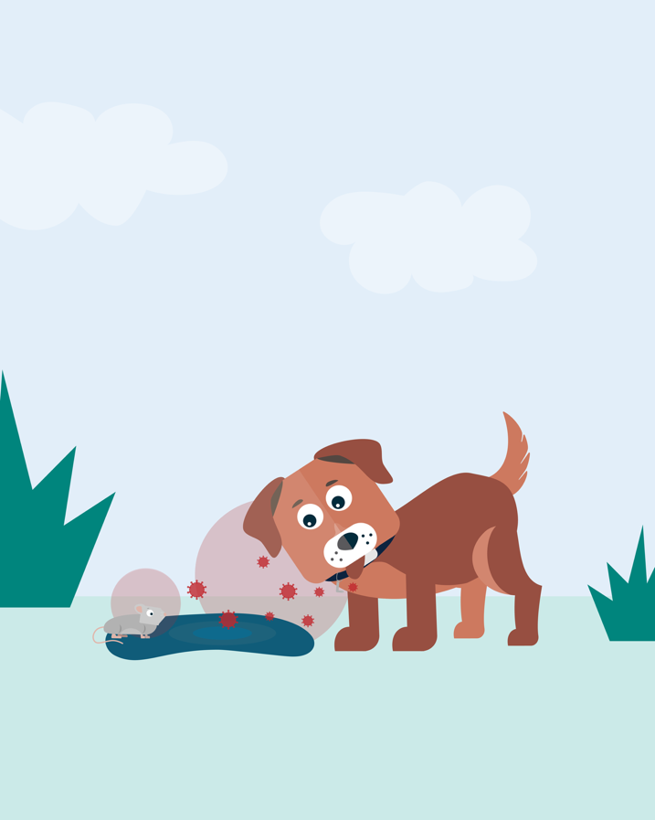
X (1600x900px)
Instagram (1080x1350px)
Facebook (1080x1350px)
Social Media Posts (cont’d)
For text: Copy and paste straight from this document onto your clinic’s social media page.
For images: Right-click and ‘Save as Picture’ to your files, then upload to your social media page from your saved files.
Post #2
Leptospirosis is a serious disease that can spread from dogs to people. Dogs can suffer from all sorts of signs, so it can be hard to spot. Signs range from fever and tummy problems to liver / kidney failure and sudden death. Protect your pet and your family. Talk to us about vaccinating your dog against leptospirosis.
Even healthy-looking dogs can spread disease, and adult dogs need yearly boosters to stay protected. Find out more: uk.mypet.com/vaccinate/

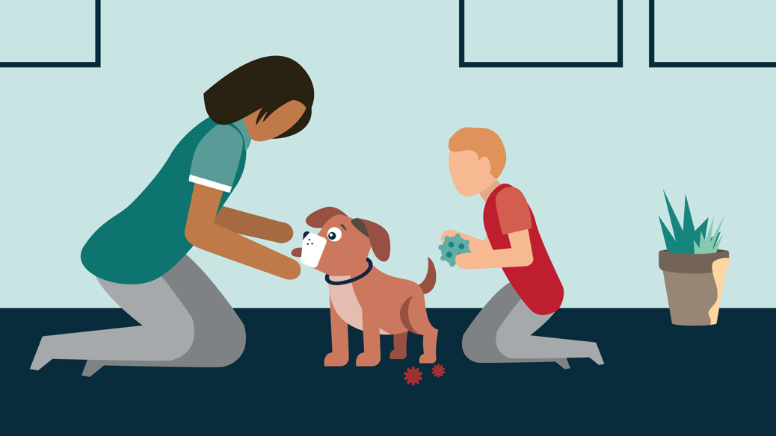
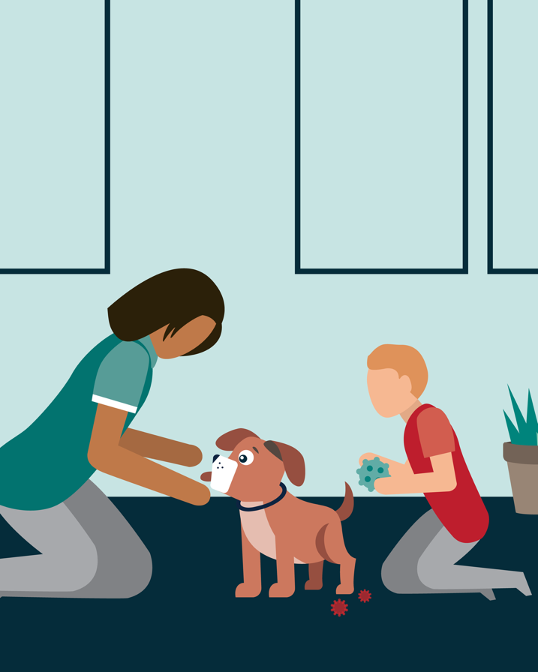
Instagram (1080x1350px)
X (1600x900px)
Facebook (1080x1350px)
Social Media Posts (cont’d)
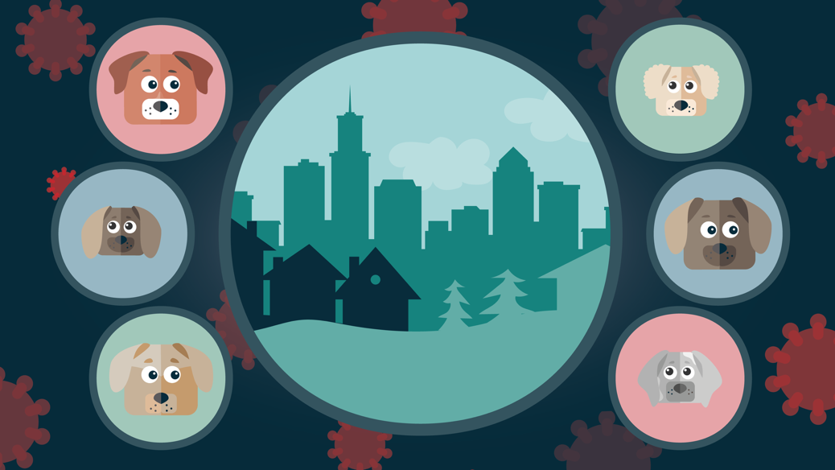
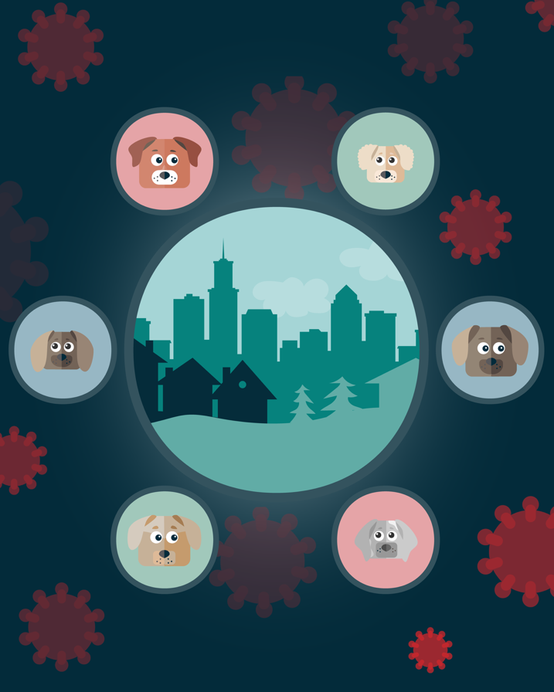
Instagram (1080x1350px)
For text: Copy and paste straight from this document onto your clinic’s social media page.
For images: Right-click and ‘Save as Picture’ to your files, then upload to your social media page from your saved files.
X (1600x900px)
Facebook (1080x1350px)
Post #3
Any age. Any breed. Any lifestyle. All dogs can be at risk for leptospirosis, which is why protection is essential. Leptospirosis is a bacterial disease which is widespread in the UK and can be rapidly fatal in dogs and humans. Talk to us today about getting your dog vaccinated.
Even healthy-looking dogs can spread disease, and adult dogs need yearly boosters to stay protected. Find out more: uk.mypet.com/vaccinate/
Social Media Posts (cont’d)

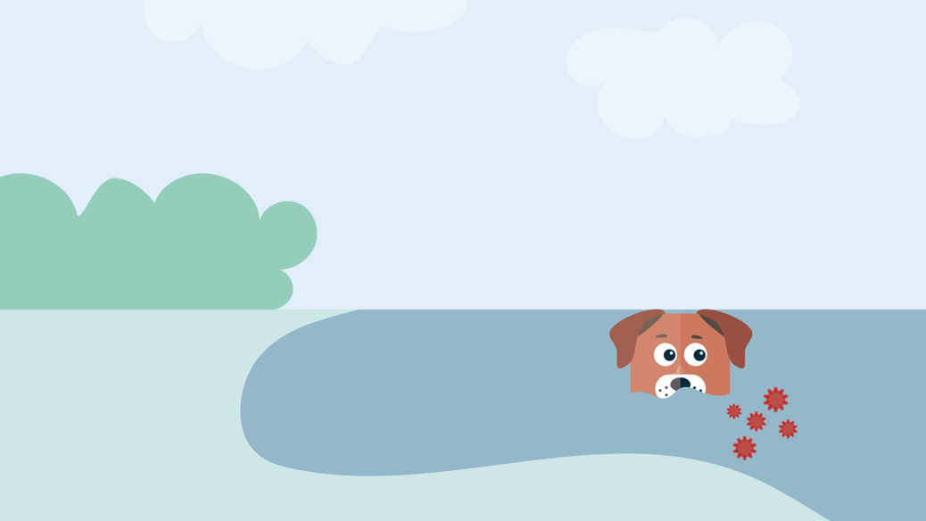
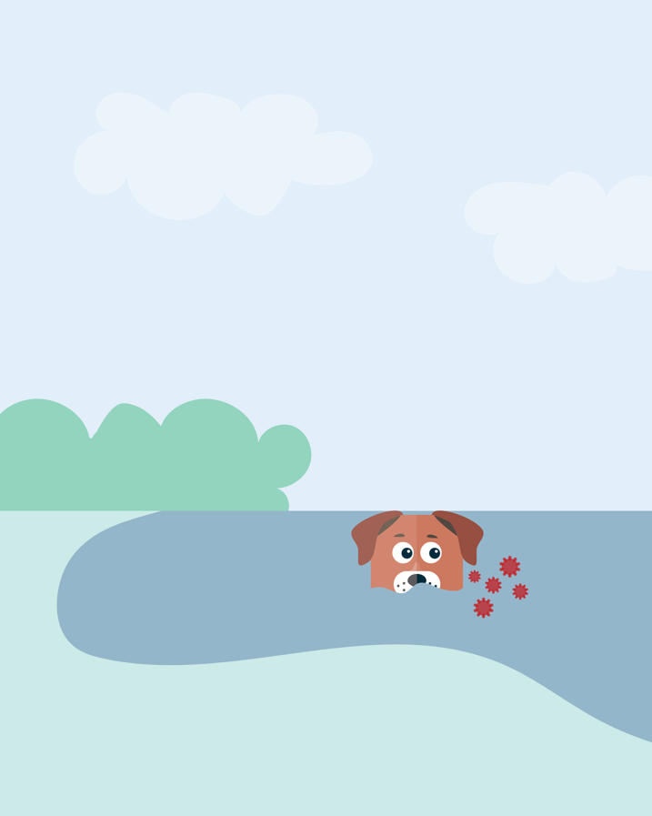
Post #4
Does your dog love splashing around in damp places like ditches, ponds, lakes and alongside
rivers? Water play is fun, but it can also expose them to leptospirosis, a potentially fatal disease.
Speak to your vet about protecting your dog today.
Even healthy-looking dogs can spread disease, and adult dogs need yearly boosters to stay
protected. Find out more: uk.mypet.com/vaccinate/
Instagram (1080x1350px)
For text: Copy and paste straight from this document onto your clinic’s social media page.
For images: Right-click and ‘Save as Picture’ to your files, then upload to your social media page from your saved files.
X (1600x900px)
Facebook (1080x1350px)
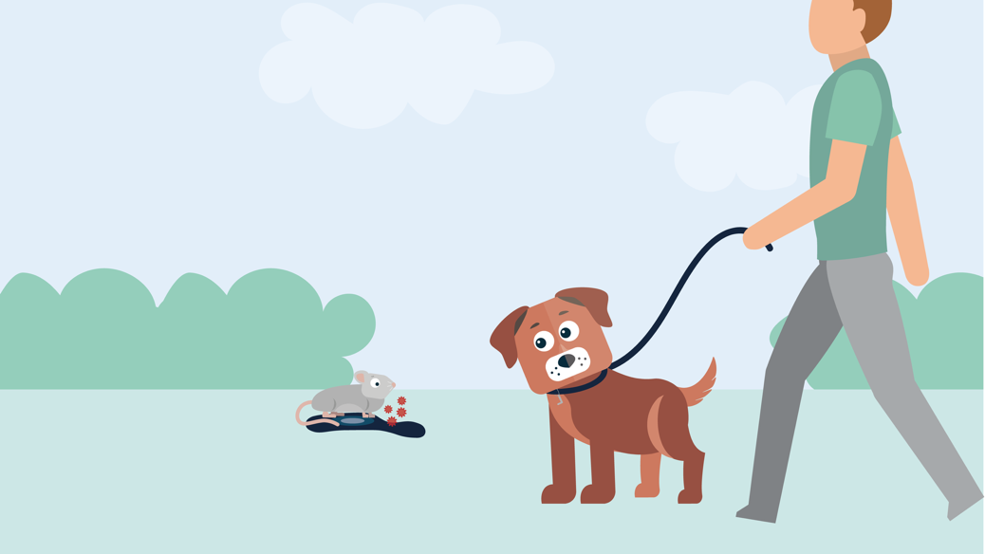
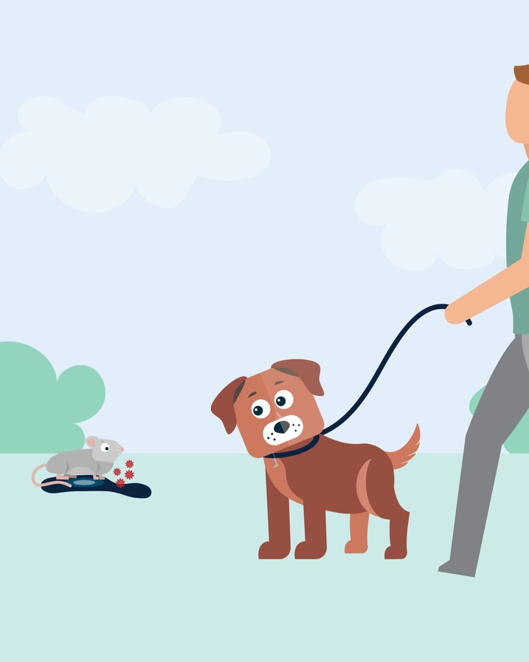
Instagram (1080x1350px)
Social Media Posts (cont’d)
For text: Copy and paste straight from this document onto your clinic’s social media page.
For images: Right-click and ‘Save as Picture’ to your files, then upload to your social media page from your saved files.
X (1600x900px)
Facebook (1080x1350px)
Post #5
Exploring is a huge part of a dog’s day, but it can also expose them to leptospirosis, a serious disease spread through the urine of infected dogs and rodents. Talk to us about how yearly vaccination can help keep everyday adventures safe.
Even healthy-looking dogs can spread disease, and adult dogs need yearly boosters to stay protected. Find out more: uk.mypet.com/vaccinate/
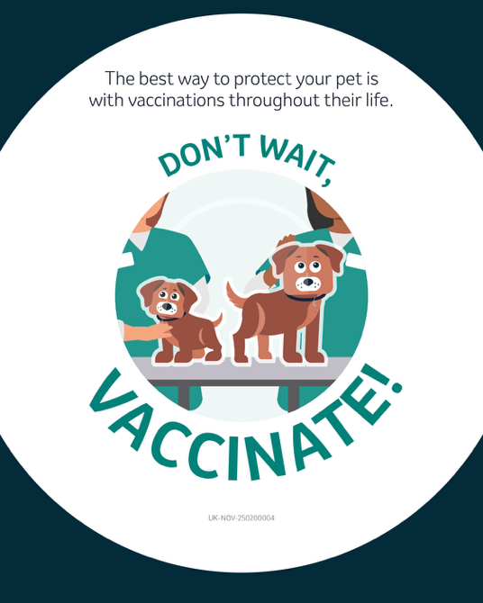
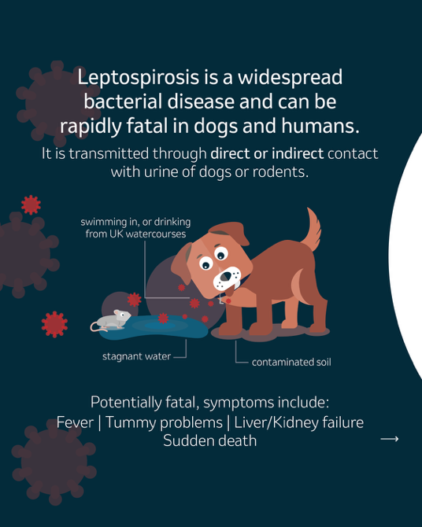
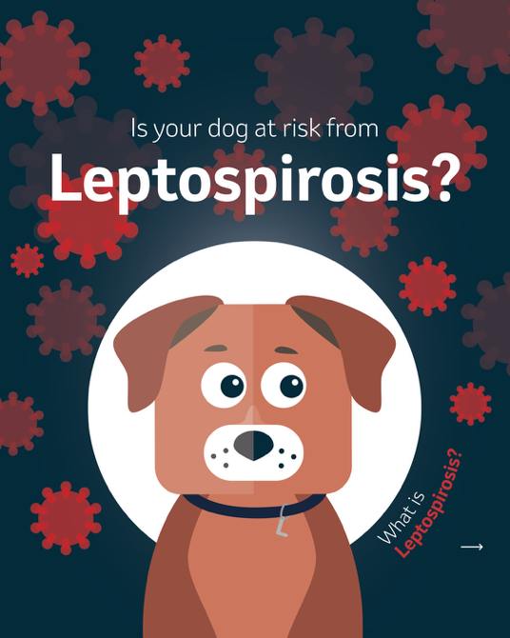
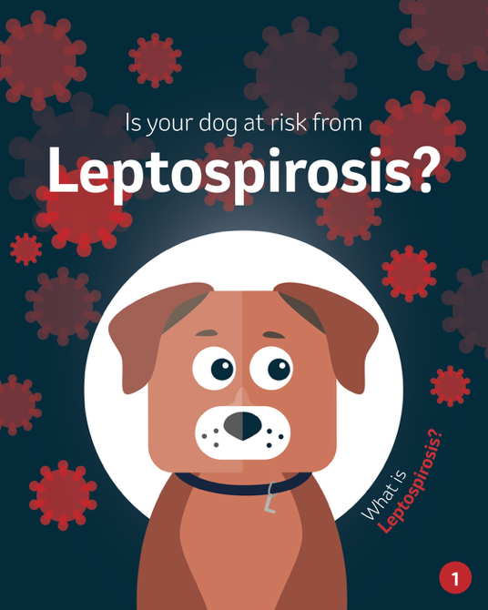
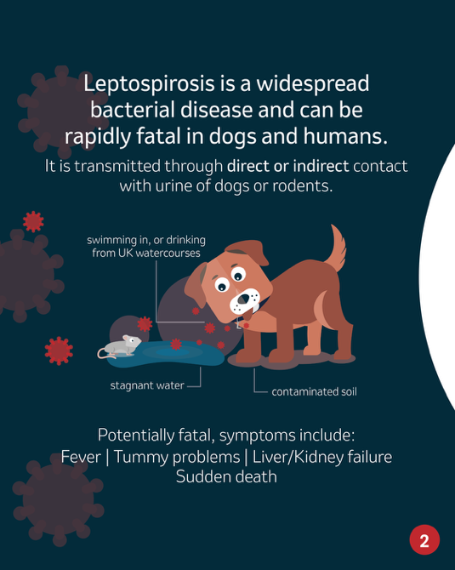
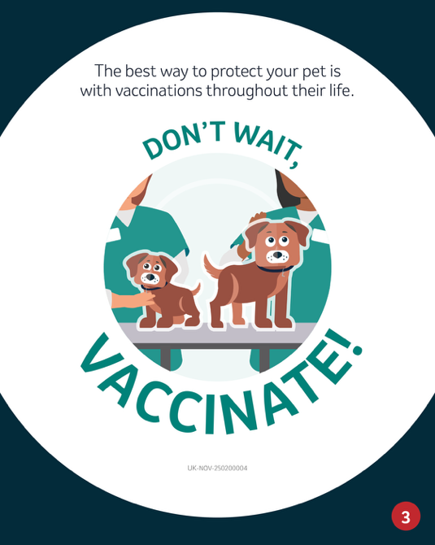
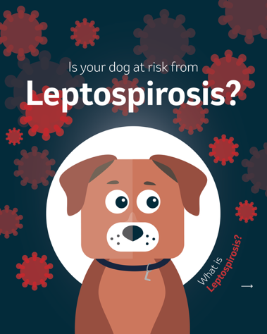
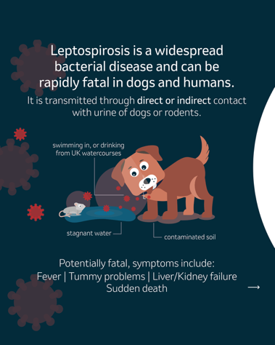
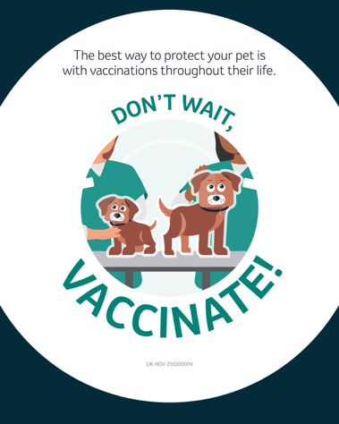
Instagram (1080x1350px)
Facebook and X (1080x1350px)
Social Media Posts (cont’d)
For text: Copy and paste straight from this document onto your clinic’s social media page.
For images: Right-click and ‘Save as Picture’ to your files, then upload to your social media page from your saved files.
Post #6
Is your dog at risk from leptospirosis? Come and speak to us today about how to protect your dog via a simple vaccine.
Even healthy-looking dogs can spread disease, and adult dogs need yearly boosters to stay protected. Find out more: uk.mypet.com/vaccinate/

