Social Media Posts
Instructions:
For text: Copy and paste straight from this document onto your clinic’s social media page.
For images: Right-click and ‘Save as Picture’ to your files, then upload to your social media page from your saved files.
Post #1
What is Contagious Cough and is my dog at risk?
Speak to us about Contagious Cough today.
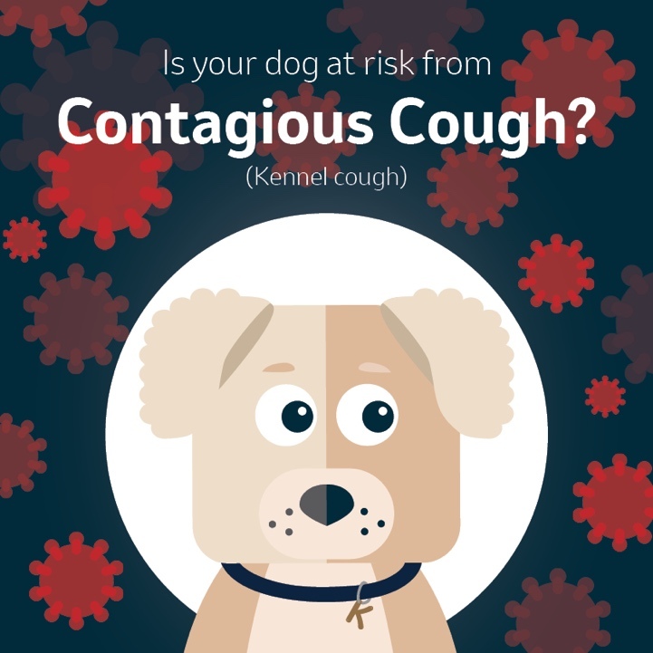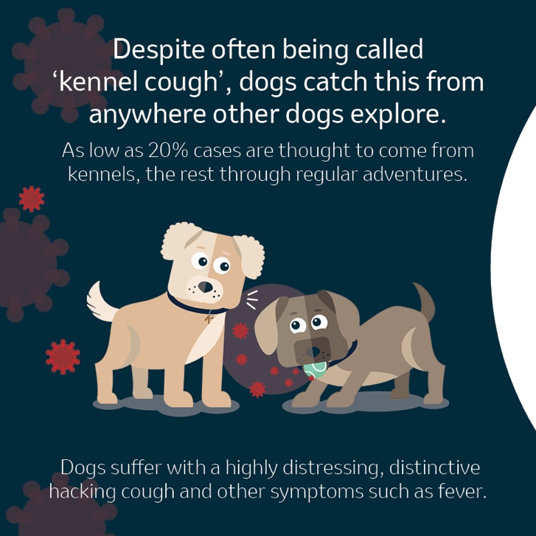
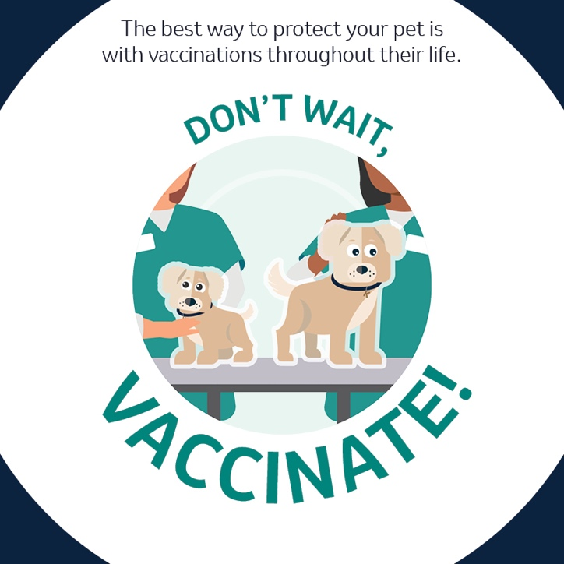

Social Media Posts
Post #2
🐶 Contagious cough is widespread, distressing and highly contagious ⚠️
Cases are seen frequently in unvaccinated dogs, caught from anywhere other dogs explore; the park, daycare, training classes, playing with dogs in your back garden, shared water bowls...
Yearly vaccination throughout life is the best way to protect your dog and reduce the spread. Check with your vet today if your dog’s vaccinations are up to date.
Find out more: uk.mypet.com/vaccinate/

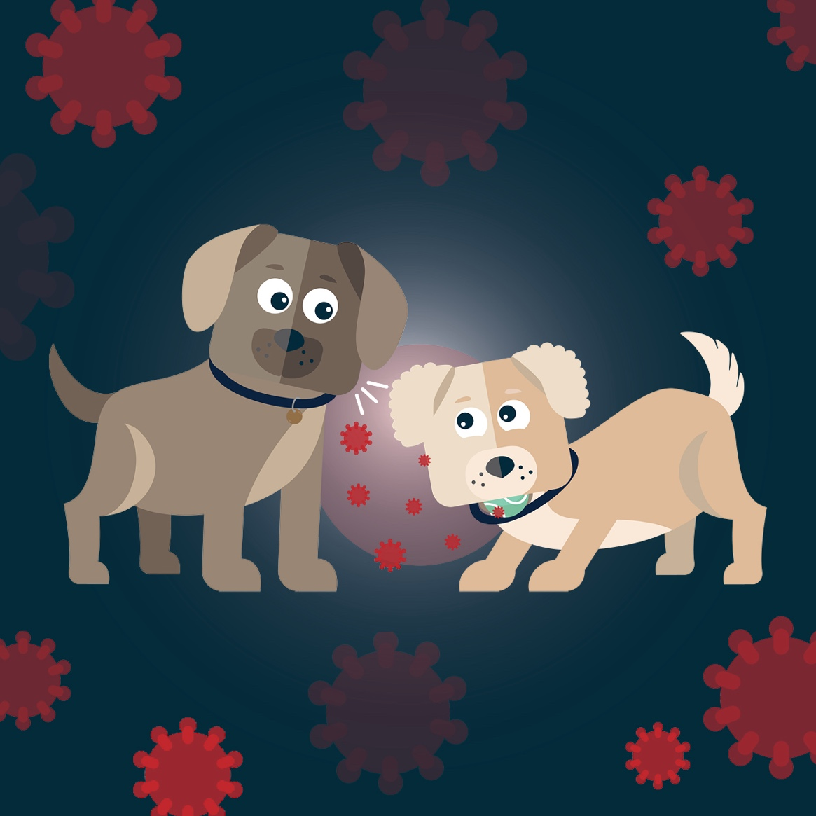

Social Media Posts
Post #3
Is your dog at risk of contagious cough?
Dogs of all ages and breeds are at risk!
Previously called kennel cough, dogs are more likely to catch this during routine adventures such as visiting the park, or drinking from a
shared water bowl.
Prevention is better than cure!
Find out more: uk.mypet.com/vaccinate/



Social Media Posts
Post #4
Contagious cough, also known as Kennel Cough and Canine Cough, spreads between dogs the same way that the common cold spreads in humans—through direct contact, via aerosol spread like coughing or sneezing, or indirectly via infection on contaminated objects such as shared chews, toys or water bowls.
If you’re concerned, speak to us about options for vaccination against contagious cough.

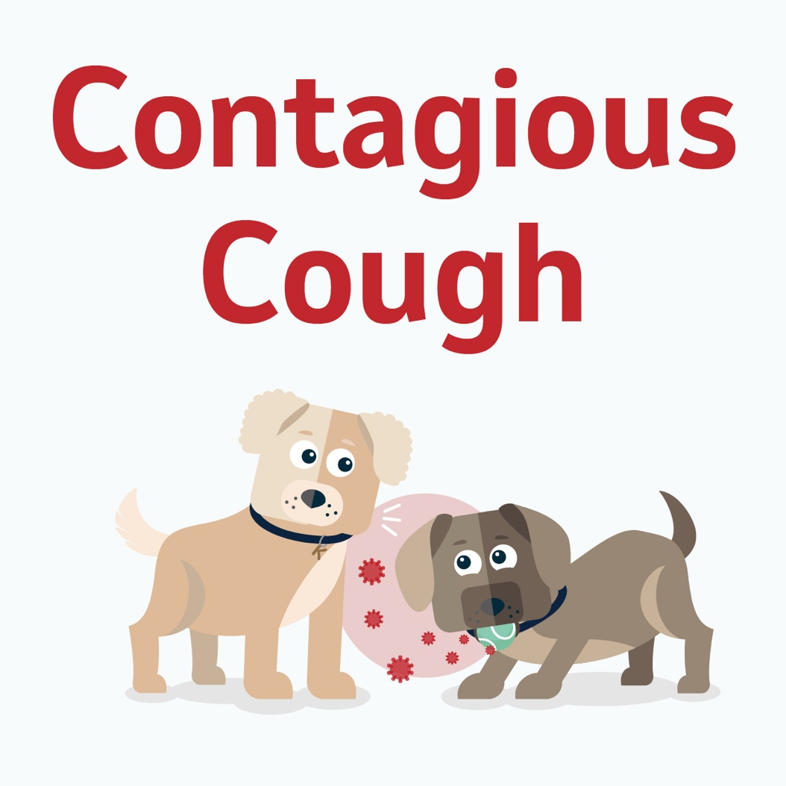

Social Media Posts
Post #5
Contagious cough is a common and occasionally serious infection that spreads through infected aerosol droplets in the air or on contaminated objects. Dogs sharing the same air space can become infected and certain venues and activities can raise your dog’s risk such as dog shows, dog parks, doggy daycares, kennels and even daily walks.
Call us on [practice phone number] if you’re concerned about your dog catching contagious cough.

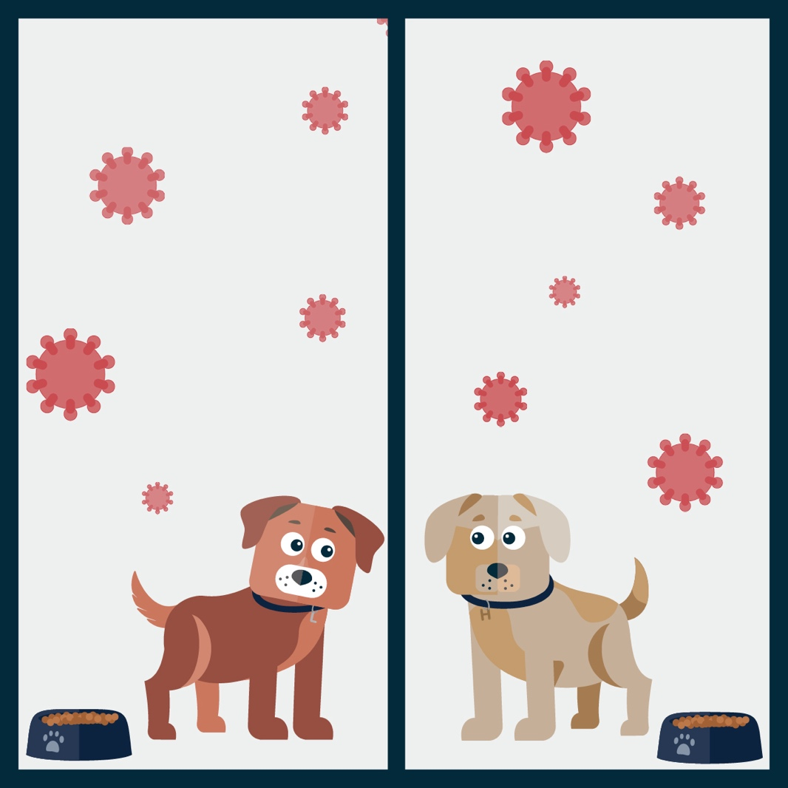

Social Media Posts
Post #6
Does your dog…
• Meet other dogs on their daily walks?
• Visit the park?
• Meet other dogs in the street?
• Go to dog daycare or boarding kennels?
• Have play dates or live in a multi-dog home?
If you answered YES to one or more of these questions, your dog is potentially at risk.
Fortunately, we can protect your dog from canine cough through regular vaccinations. Contact our veterinary practice today and get your dog vaccinated against this disease.
[customise with practice phone number, email, and/or website].



Social Media Posts
Post #7
[Give short detail of location and date CC was seen]
The best way to protect your dog is through vaccinations.
Unvaccinated dogs are at risk from serious health issues. Don’t wait, vaccinate!
Option 1:
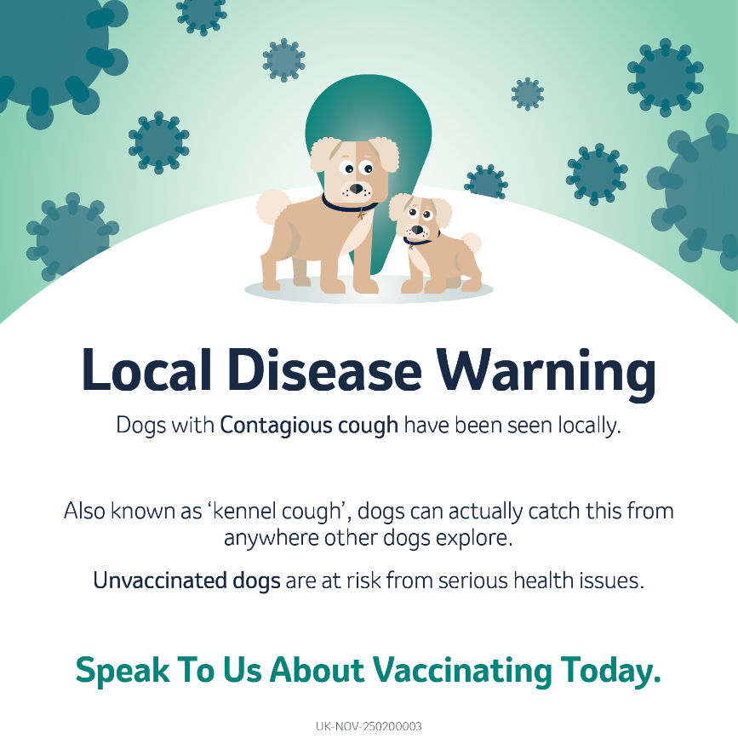
Option 2:
