DOG OWNER EMAIL
SUBJECT: <dog name> is at risk.

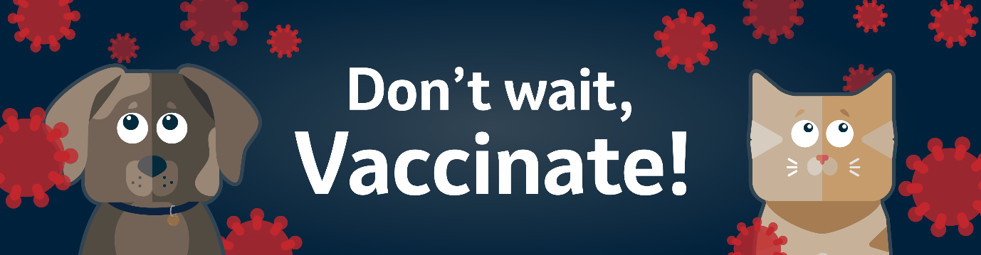

Dear <pet owner name>,

Did you know everyday adventures put your dog at risk of disease?
These are generally difficult to treat, can be life-threatening and some can even affect humans.

Our records show that <dog name> is overdue their vaccinations and is therefore unprotected.
Please call us on <practice phone number> or click <here> to book them in.

Vaccinations throughout life are important for the ongoing protection of your dog against life-threatening illnesses such as parvovirus. Some vaccines are required yearly to stay protected such as leptospirosis and contagious canine cough (aka kennel cough).
Unvaccinated dogs are not only at higher risk of catching diseases, they're also more likely to pass them on to other dogs.

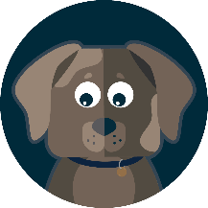
Your vet will give <dog name> a thorough health check followed by the vaccination, to ensure everything is in paw-fect order.
Our health plan can help give <dog name> the best protection, whilst allowing you to make savings and spread the cost. Click <here> to find out more.

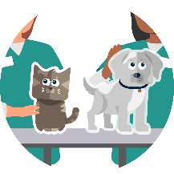
Protect everyday adventures. Don’t wait, vaccinate!
We look forward to seeing you and <dog name> soon.
<vet practice name>

CAT OWNER EMAIL
SUBJECT: <cat name> is at risk.

Dear <pet owner name>,

Did you know everyday adventures put your cat at risk of disease?
These are generally difficult to treat and can be life-threatening.

Our records show that <cat name> is overdue their vaccinations and is therefore unprotected.
Please call us on <practice phone number> or click <here> to book them in.

Vaccinations throughout life are important for the ongoing protection of your cat against life-threatening illnesses such as feline panleukopaenia and feline leukaemia virus. Some vaccines are required yearly to stay protected such as cat flu.

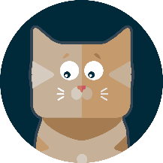
Your vet will give <cat name> a thorough health check, followed by the vaccinations they need, to ensure everything stays in paw-fect order.
Our health plan can help give <cat name> the best protection, whilst allowing you to make savings and spread the cost. Click <here> to find out more.

Protect everyday adventures. Don’t wait, vaccinate!
We look forward to seeing you and <cat name> soon.
<vet practice name>

DOG OR CAT SMS

<pet owner name> our records show <pet name> is unprotected and could be at risk. Annual vaccination is one of the best ways to protect <pet name> from potentially serious illnesses. Everyday adventures put your pet at risk. Don’t wait, vaccinate! Call <or click here> to book.

