Parvovirus

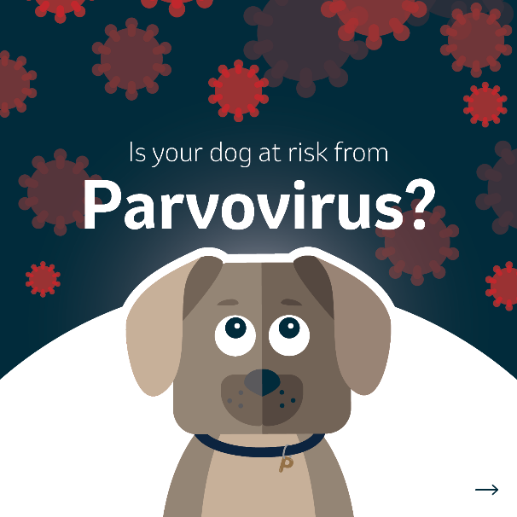 | 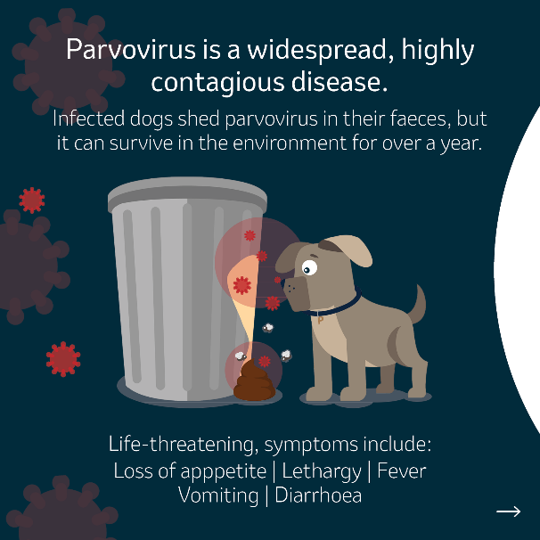 | 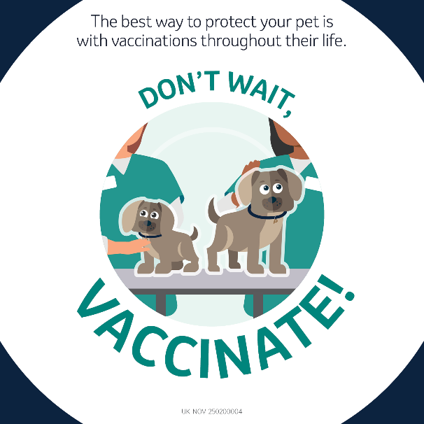
Suggested Caption:

🐶Parvovirus is widespread, life-threatening & highly contagious.⚠️

Cases are seen frequently in unvaccinated dogs due to the ability of the virus to survive in the environment for over a year with resistance to commonly used disinfectants and freezing temperatures.

The best way to protect your dog is with regular vaccinations throughout their life. Unvaccinated dogs are at risk and it is usually fatal without intensive treatment. Check with your vet today if your dog’s vaccinations are up to date.

#IAmProtected

Leptospirosis

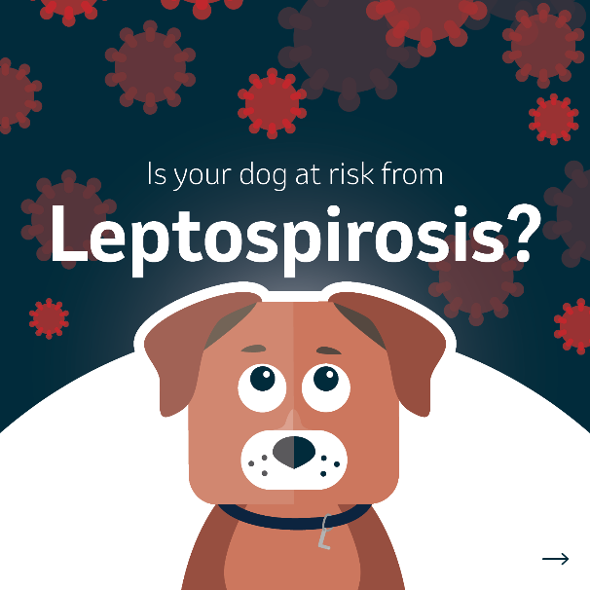 | 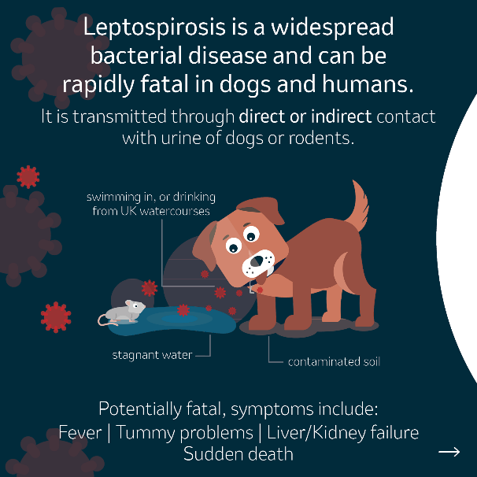 | 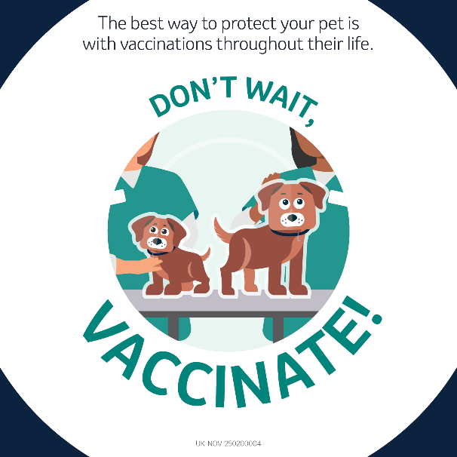
Suggested Caption:

🐶Leptospirosis is caused by a widespread bacteria and can be fatal.⚠️

Cases are seen frequently in unvaccinated dogs in the UK. All dogs are at risk regardless of their age, breed and lifestyle and there is often a spike in cases after local flooding.

Yearly vaccination throughout life is the best way to protect your dog and reduce the spread. Check with your vet today if your dog’s vaccinations are up to date.

#IAmProtected

Contagious cough (aka kennel cough)

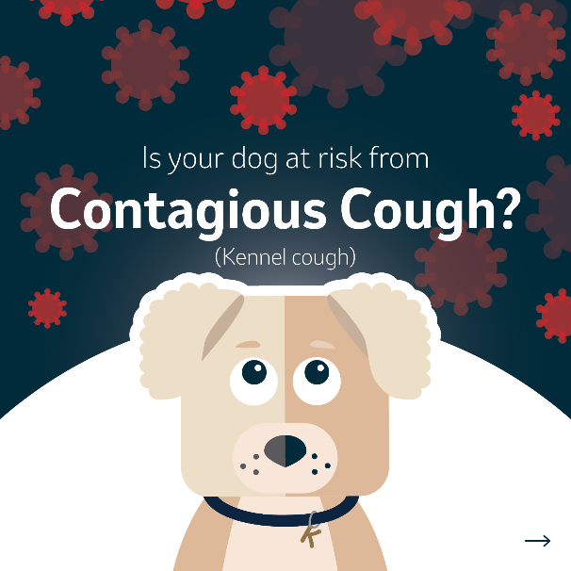 | 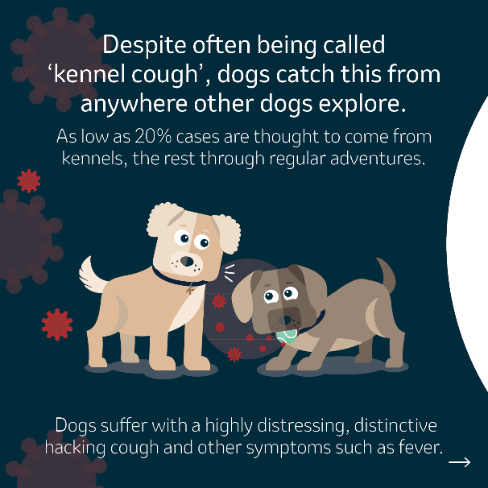 | 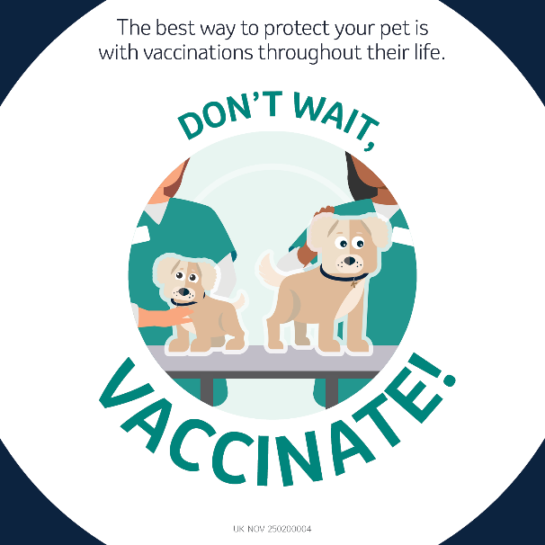
Suggested Caption:

🐶Contagious cough is widespread, distressing and highly contagious.⚠️

Cases are seen frequently in unvaccinated dogs, caught from anywhere other dogs explore; the park, daycare, training classes, shared water bowls outside shops...

Yearly vaccination throughout life is the best way to protect your dog and reduce the spread. Check with your vet today if your dog’s vaccinations are up to date.

#IAmProtected

Distemper

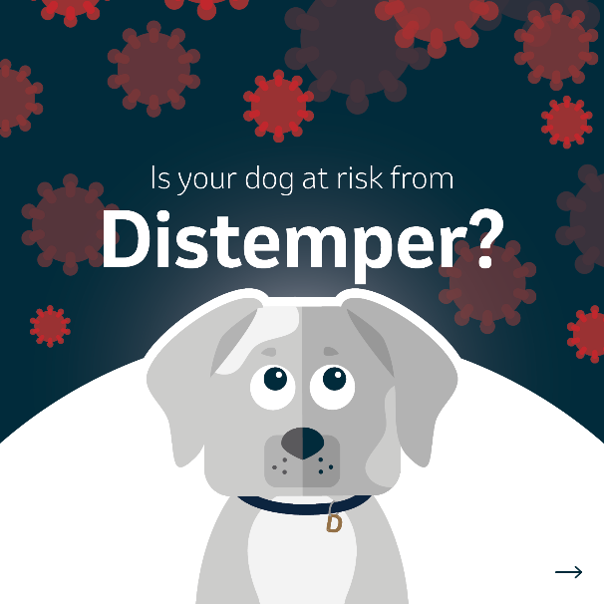 | 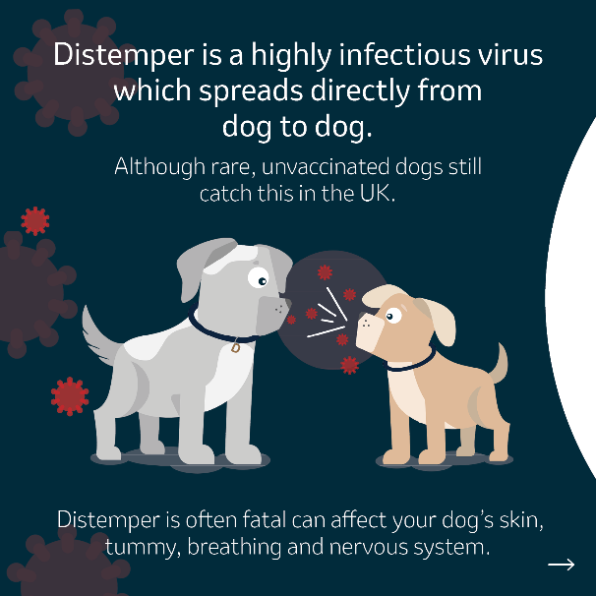 | 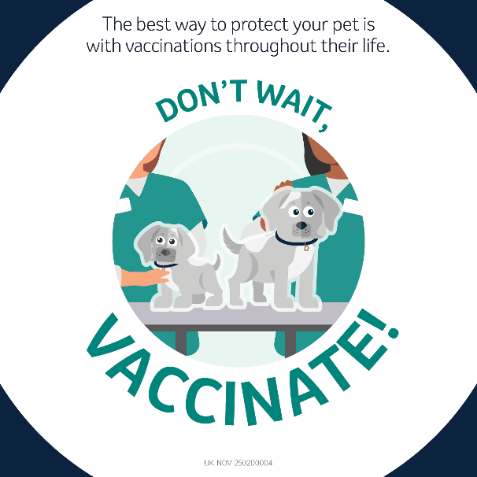
Suggested Caption:

🐶Distemper is highly infectious & often fatal.⚠️

Cases are still seen in the UK in unvaccinated dogs as it spreads easily from dog to dog.

The best way to protect your dog is through regular vaccinations throughout their life. This not only protects them, but also decreases the spread of disease. Check with your vet today if your dog’s vaccinations are up to date.

#IAmProtected

Infectious hepatitis (Canine adenovirus)

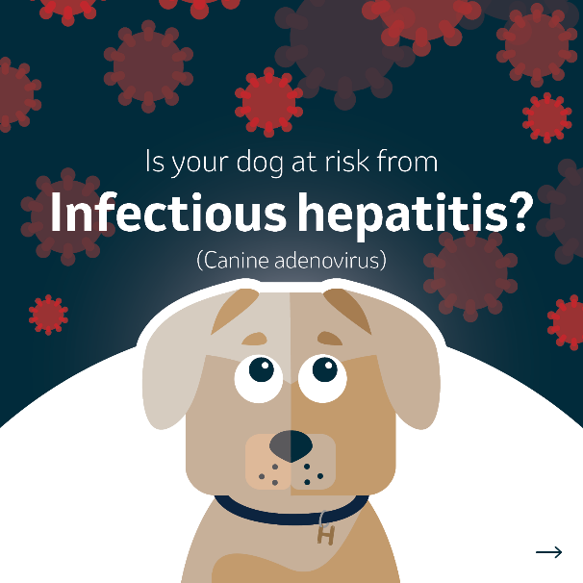 | 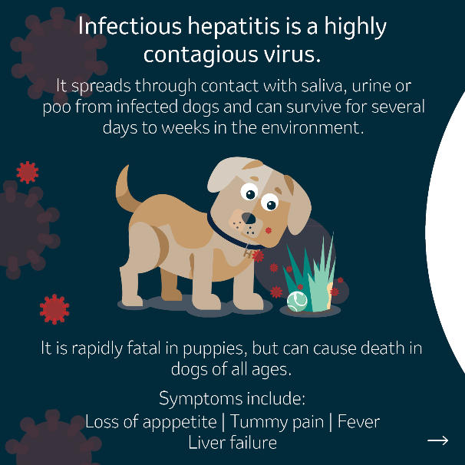 | 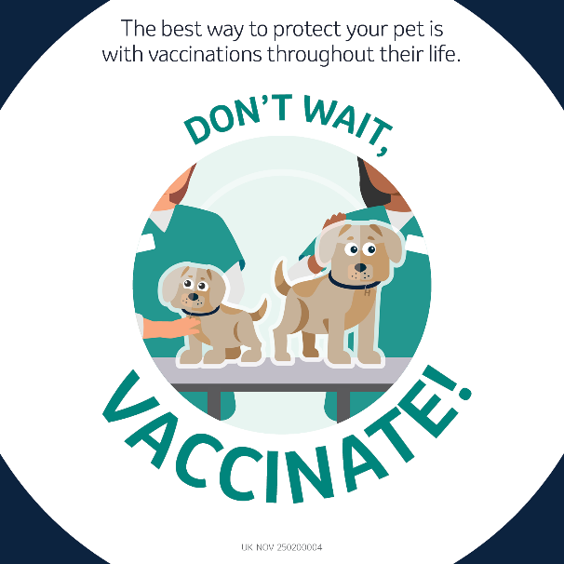
Suggested Caption:

🐶Infectious hepatitis is highly contagious & potentially fatal.⚠️

Although thankfully rare in the UK thanks to vaccinations, cases are still seen in unvaccinated dogs due to the ability of the virus to survive in the environment.

The best way to protect your dog is through regular vaccinations throughout their life. This not only protects them, but also decreases the spread of disease. Check with your vet today if your dog’s vaccinations are up to date.

#IAmProtected

Cat flu (Herpesvirus & Calicivirus)

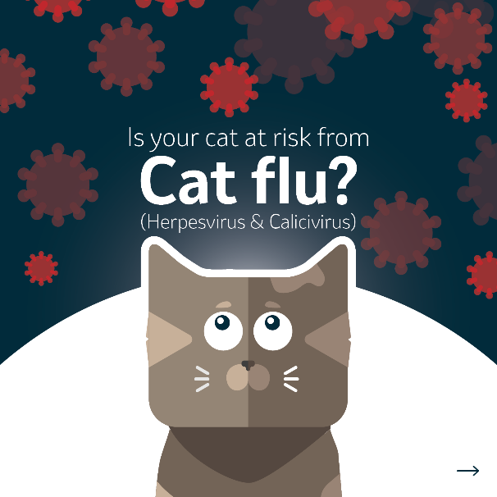 | 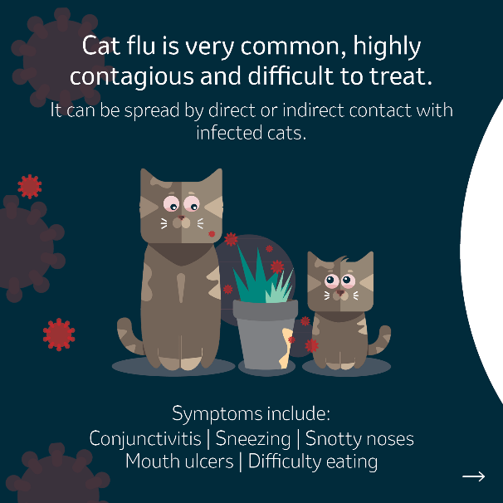 | 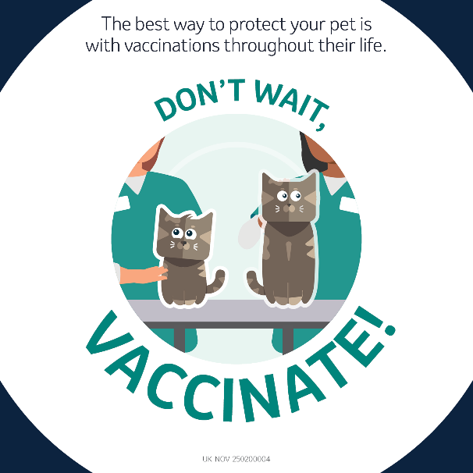
Suggested Caption:

🐱Cat flu is widespread, debilitating & highly contagious.⚠️

Cases are seen frequently in unvaccinated cats due to the virus being spread by direct or indirect contact with infected cats, which means your cat can catch it from an area an infected cat has explored.

The best way to protect your pet is by vaccinating them every year. This not only protects them, but also decreases the spread of disease. Check with your vet today if your cat’s vaccinations are up to date.

#IAmProtected

Panleukopaenia

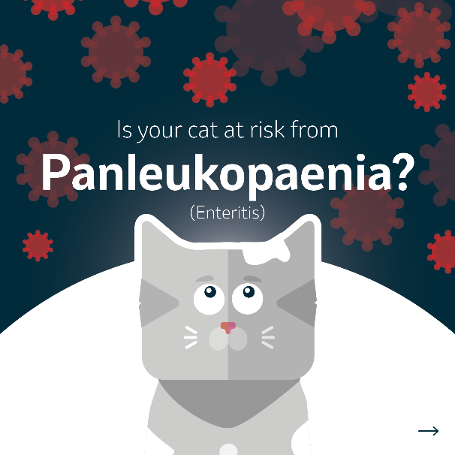 | 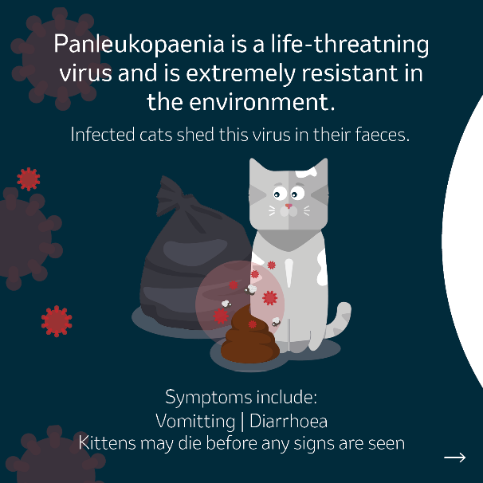 | 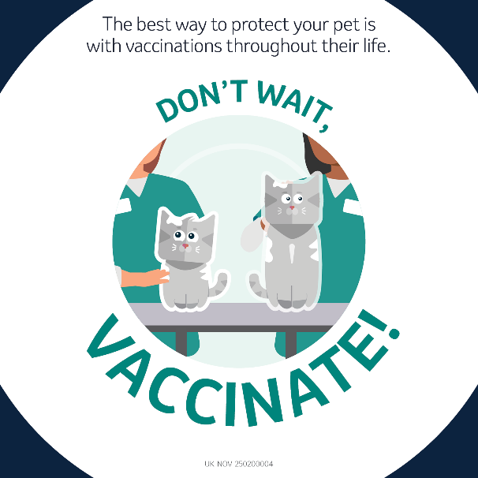
Suggested Caption:

🐱Panleukopaenia is life-threatening & highly contagious.⚠️

Cases are seen frequently in unvaccinated cats due to the virus’ ability to survive in the environment for over a year. Less than 50% of cats will survive this, even with intensive care treatment.

The best way to protect your cat is through regular vaccinations throughout their life. This not only protects them, but also decreases the spread of disease. Check with your vet today if your cat’s vaccinations are up to date.

#IAmProtected

Feline leukaemia (FeLV)

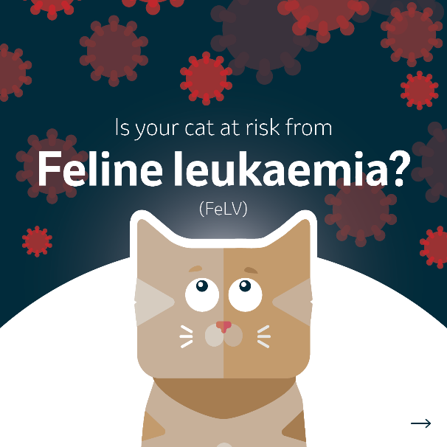 | 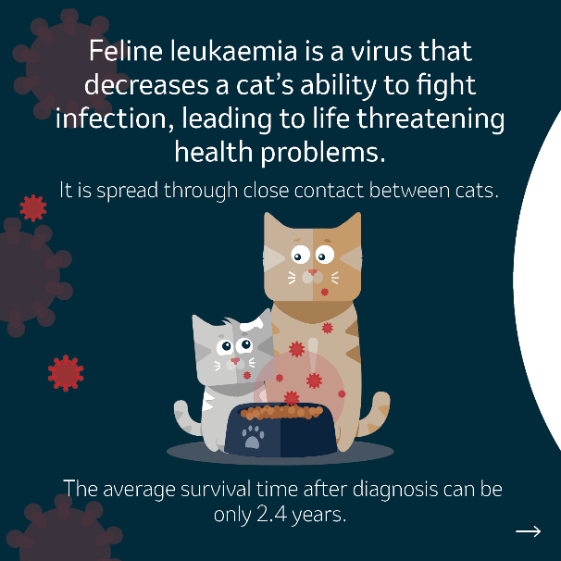 | 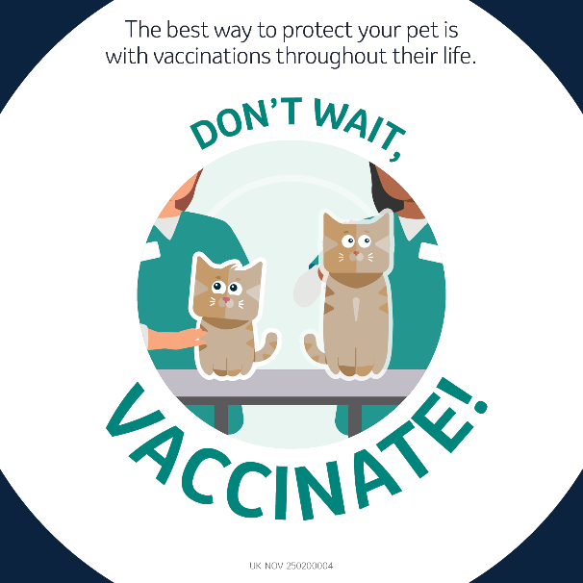
Suggested Caption:

🐱Feline leukaemia is highly contagious & life-threatening.⚠️

Once the 2nd biggest killer of young cats after traffic accidents, this virus is still seen in the UK. It decreases a cat’s ability to fight infection and affected cats develop serious health problems including cancer and anaemia.

The best way to protect your cat is through regular vaccinations throughout their life. This not only protects them, but also decreases the spread of disease. Check with your vet today if your cat’s vaccinations are up to date.

#IAmProtected

