🚨 New Microchipping Law 🚨  It is a legal requirement for all dogs over 8 weeks of age in the UK, and all cats over 20 weeks of age in England, to be microchipped and registered on a DEFRA-compliant microchip database such as HomeAgain®.  🐾👩‍⚕️ If you aren’t sure if your pet is microchipped, come into the practice and we can check. If you want to register, or aren’t sure where your pet’s microchip is registered, head to homeagain.co.uk! | 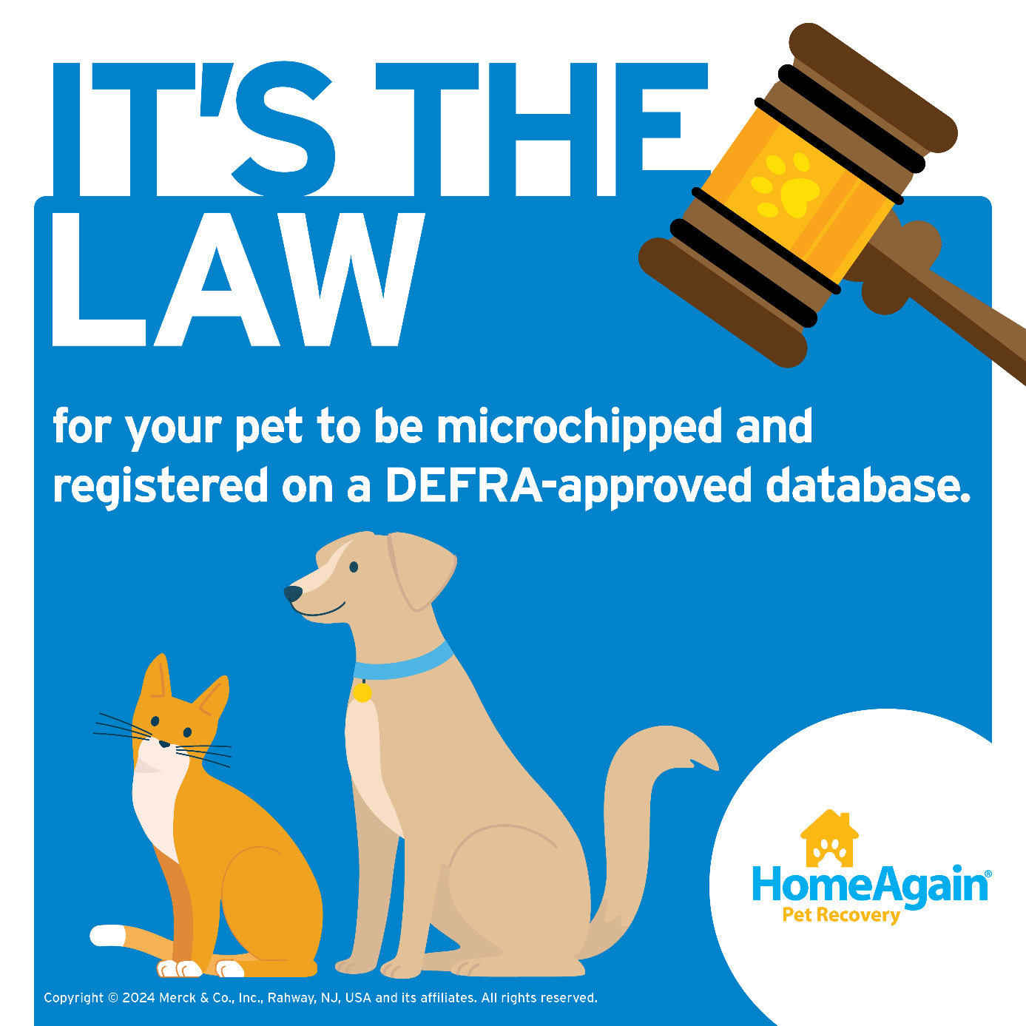
We are excited to announce that we now stock HomeAgain® Thermochip® microchips!!!  The HomeAgain Thermochip is a new generation of identification microchip that incorporates an integrated temperature biosensor. 🌡️ This enables an animal's temperature and identification number to be read simultaneously through a non-invasive stress-free method. 🐶 🐱  Come visit our practice to ask about Thermochip today! | 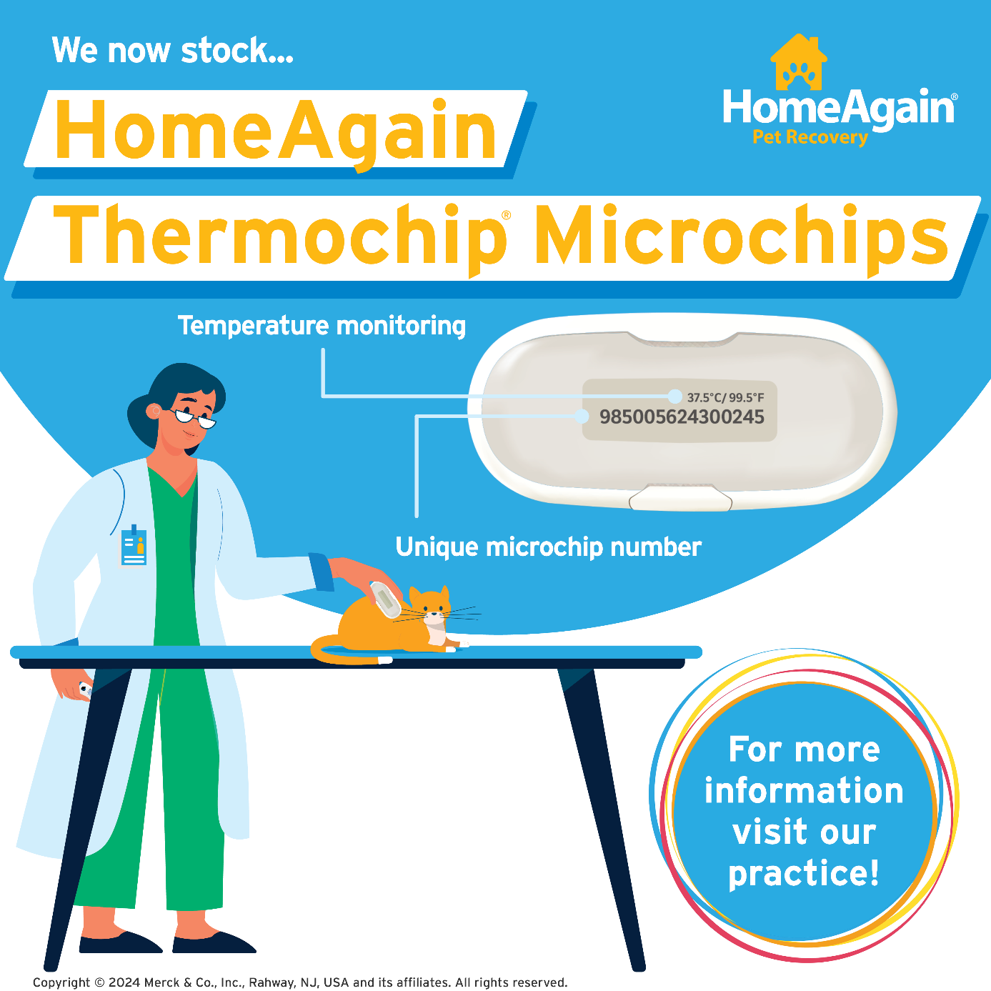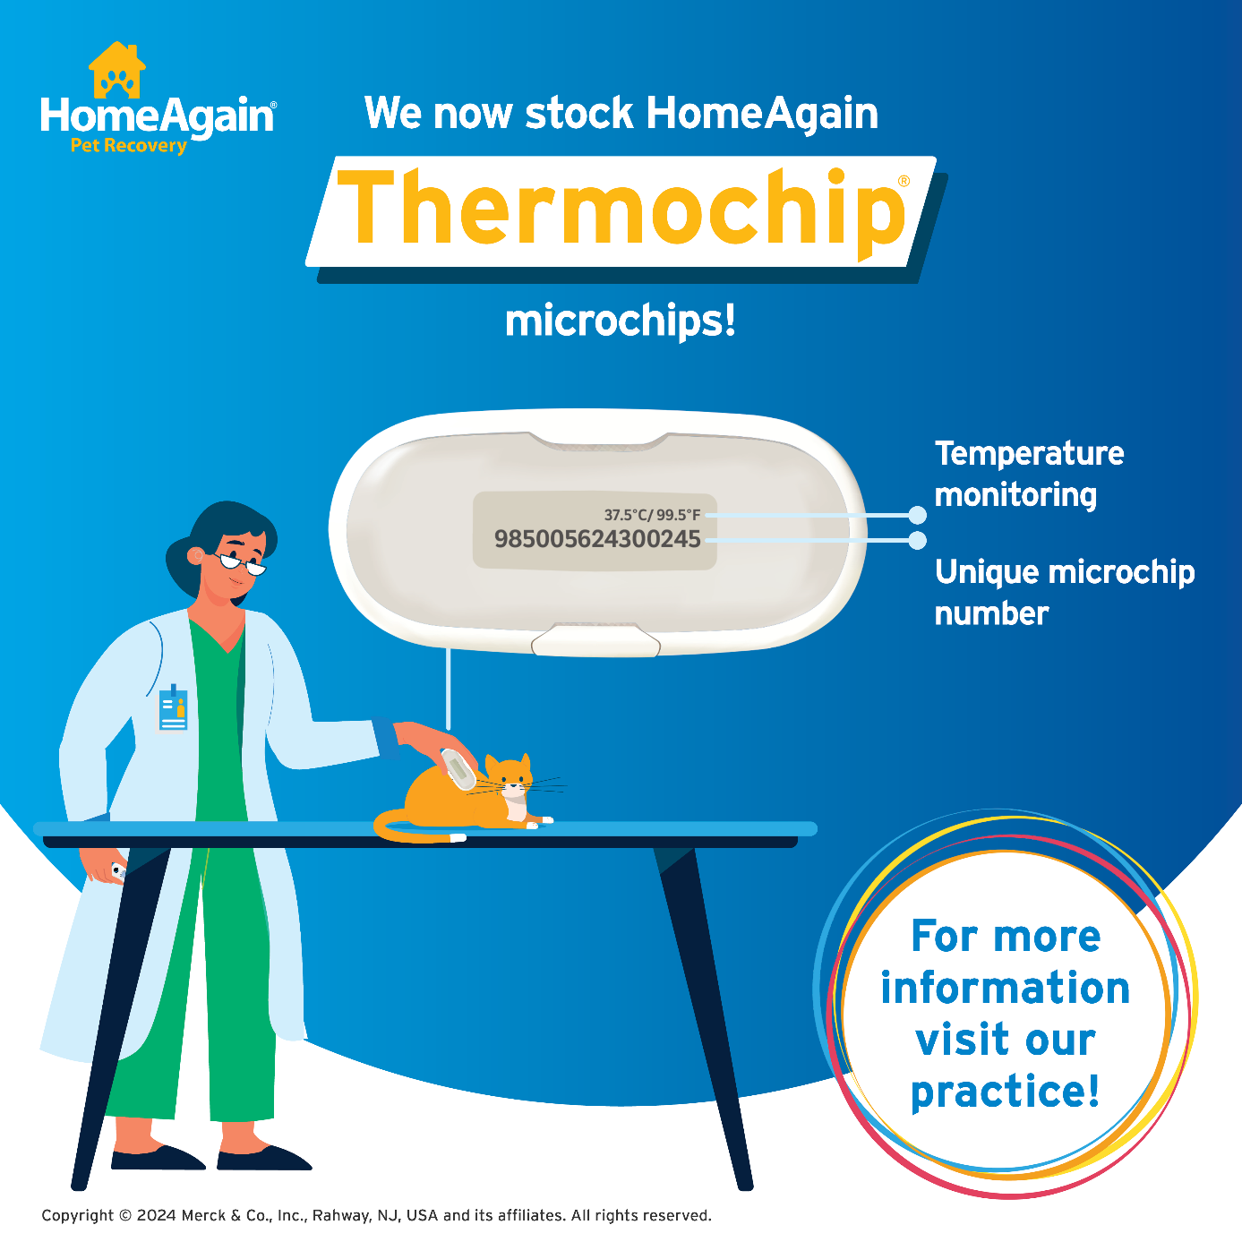
To check if your pets are microchipped and registered on a database, visit homeagain.co.uk/check-the-chip 🐕  If you aren't sure if your cat or dog is microchipped, book an appointment with us. They must be microchipped by law!  If your pet is microchipped but you have not registered them in a microchip database, your pet is not fully protected! Register your pet’s microchip at homeagain.co.uk today or come into the practice to find out more! | 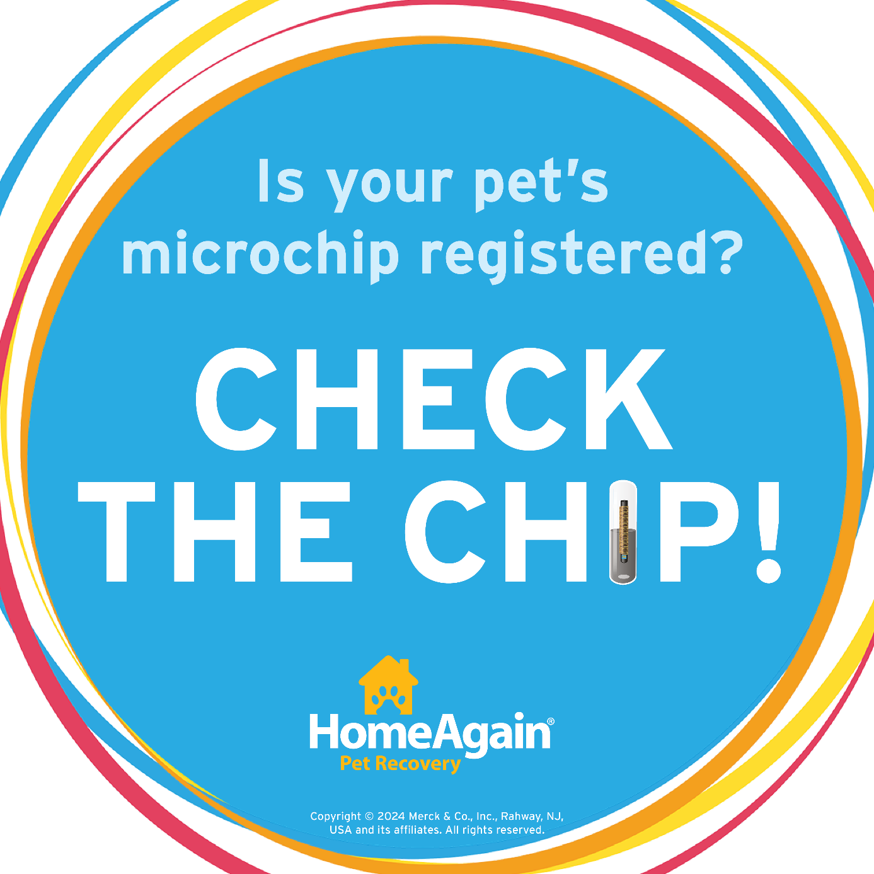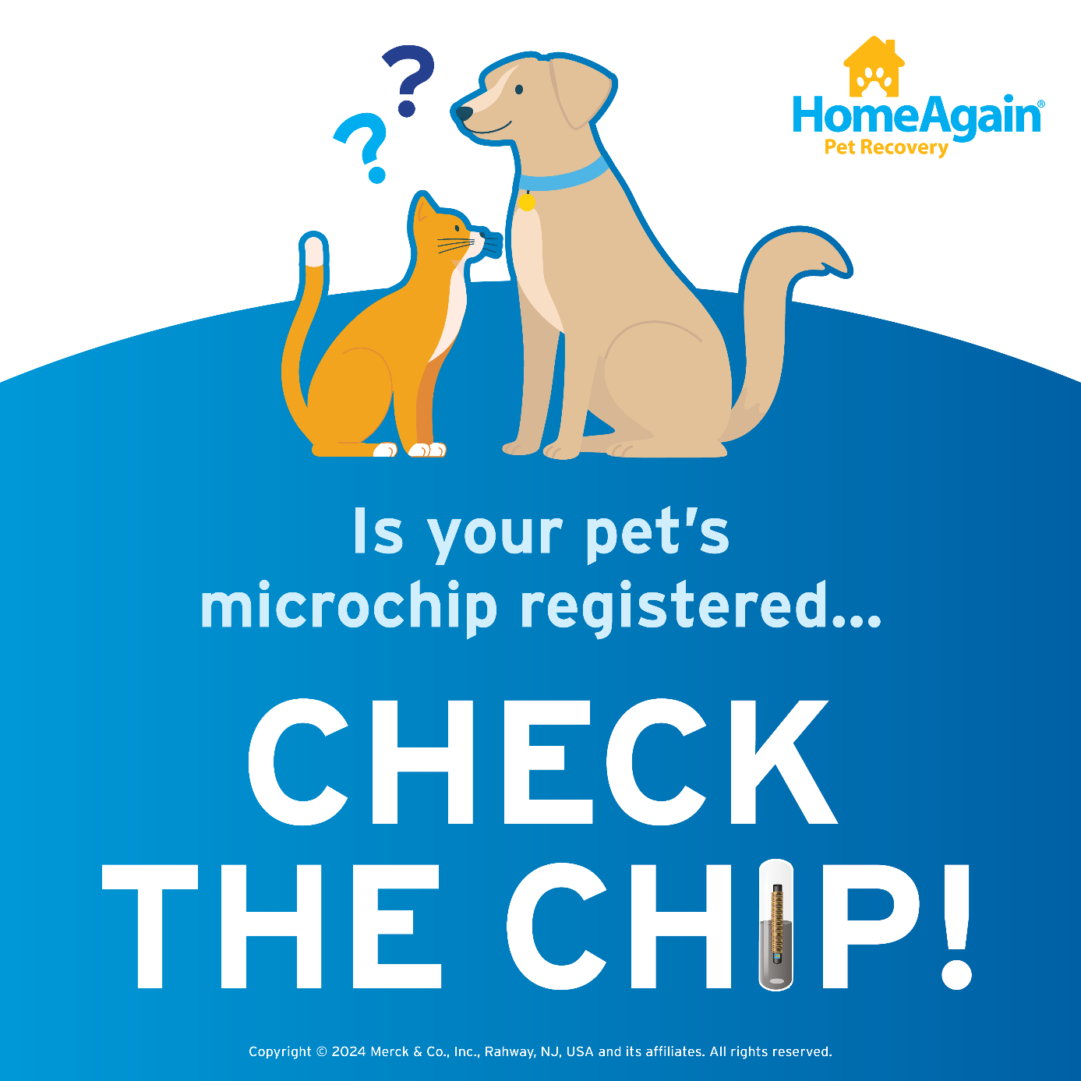
We use HomeAgain’s 100% free DEFRA-compliant Microchip Database 💙  Register your pet's microchip with HomeAgain and your contact information will be connected to their microchip's unique ID number. 🐶 🐱  🔍 If your pet ever becomes lost, we can scan their microchip to contact you and reunite you with your pet!  Register your pet’s microchip at homeagain.co.uk today or come into the practice to find out more! | 